

**KALLAM HARANADHAREDDY INSTITUTE OF TECHNOLOGY  
(AUTONOMOUS)**

Furnish Fusion: Your Online Destination for Stylish Living

**By:**

**KUKKALA SAI MAHESWARI**

[218x1a1219@khitguntur.ac.in](mailto:218x1a1219@khitguntur.ac.in)

**ANNEM SUJATHA**

[218x1a1202@khitguntur.ac.in](mailto:218x1a1202@khitguntur.ac.in)

**KORLAPATI VENKATA DIVYA SAI BABU**

[228x5a1203@khitguntur.ac.in](mailto:228x5a1203@khitguntur.ac.in)

**SIRIGIRI CHIDVILASH CHOWDARY**

218x1a1247@khitguntur.ac.in

**Furnish Fusion: Your Online Destination for Stylish Living**

**Project Description:**

In today’s dynamic marketplace, delivering a seamless shopping experience is essential for furniture retailers. Furnish Fusion is a cloud-based furniture management system designed to enhance the online shopping journey by providing an integrated platform for browsing products, managing orders, and facilitating secure transactions.

To achieve this, the project leverages Flask for backend development, AWS EC2 for scalable hosting, Dynamo DB for efficient data management, Amazon S3 for secure image storage, AWS Lambda for automated processing, and Amazon SES for sending transactional emails. Furnish Fusion enables customers to effortlessly explore a wide range of furniture options, add items to their cart, and complete purchases—all while receiving real-time updates on their orders.

### Scenario 1: Streamlined Furniture Browsing and Ordering

In the **FurnishFusion** system, AWS EC2 provides a robust infrastructure capable of managing numerous customers browsing the platform simultaneously. For instance, a customer can log in, effortlessly explore various furniture categories, and add items to their cart. Flask handles backend operations by efficiently retrieving product data and processing user interactions in real-time. The cloud-based architecture allows the platform to accommodate a high volume of traffic during sales events, ensuring a smooth shopping experience without delays.

### Scenario 2: Secure Admin and User Management with IAM

**FurnishFusion** utilizes AWS IAM to manage user permissions and ensure secure access to the system. For example, when a new customer registers, an IAM user is created with specific roles that grant access only to the features relevant to them, such as browsing products and viewing their order history. Admin users have their own IAM configurations, allowing them to manage product listings, view customer orders, and modify inventory levels while maintaining strict security protocols. This setup ensures that sensitive data, such as customer information and financial transactions, is accessible only to authorized personnel.

### Scenario 3: Efficient Order Tracking and Notifications

The **FurnishFusion** system provides customers with easy access to their order status and notifications. For instance, after completing a purchase, a customer receives a confirmation email via Amazon SES detailing their order. They can log in to their account to view their order history and track shipping progress. Flask manages real-time data fetching from DynamoDB, while the EC2 hosting ensures that the platform performs seamlessly, even during high-traffic periods, offering a smooth and uninterrupted user experience.

**AWS ARCHITECTURE**

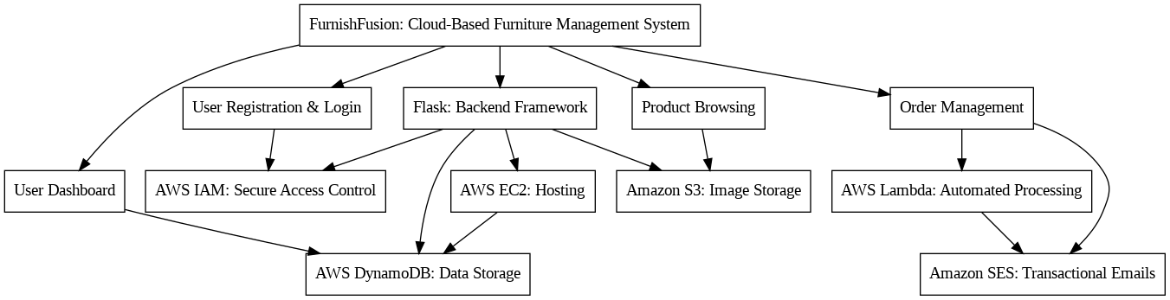

**Entity Relationship (ER) Diagram:**

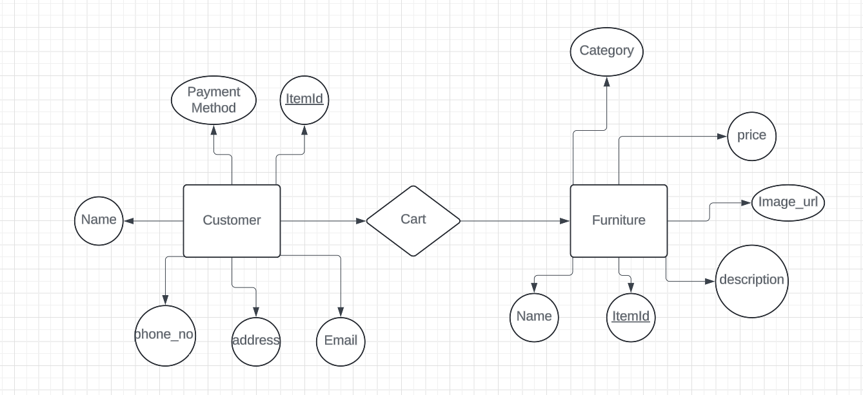

**Pre-requisites:**

### .AWS Account Setup: [AWS Account Setup](https://youtu.be/CjKhQoYeR4Q?si=ui8Bvk_M4FfVM-Dh)

### Understanding IAM: [IAM Overview](https://youtu.be/gsgdAyGhV0o?si=3qg-bULgkD4LXNvR)

### Amazon EC2 Basics: [EC2 Tutorial](https://youtu.be/8TlukLu11Yo?si=MUj0nEAOESRhHUIz)

### S3 Tutorial : [S3 Tutorial](https://youtu.be/77lMCiiMilo?si=tbejRz6DQyQ8Ggn4)

### DynamoDB Basics: [DynamoDB Introduction](https://docs.aws.amazon.com/dynamodb)

### Git Version Control: [Git Documentation](https://git-scm.com/doc)

### Project Workflow:

**Project Flow**

1. **AWS Account Setup and Login**
   * **Activity 1.1:** Set up an AWS account if not already done.
   * **Activity 1.2:** Log in to the AWS Management Console.
2. **S3 Simple Storage Service Setup:**
   * **Activity 2.1:** Create an S3 bucket
   * **Activity 2.2** : Add the images related to the furniture in the bucket
3. **DynamoDB Database Creation and Setup**
   * **Activity 3.1:** Create a DynamoDB Table.
   * **Activity 3.2:** Configure Attributes for customer data and Furniture data .
   * **Activity 3.3**: Integrate Dynamodb with s3
4. **AWS Lambda and SES Setup**
   * **Activity 4.1**: Create a lambda function.
   * **Activity 4.2**:Set Up AWS SES
5. **Backend Development and Application Setup**
   * **Activity 5.1:** Develop the Backend Using Flask.
   * **Activity 5.2:** Integrate AWS Services Using Boto3.
6. **IAM Role Setup**
   * **Activity 6.1:** Create IAM Roles for secure user access.
   * **Activity 6.2:** Attach Policies to ensure appropriate permissions.
7. **EC2 Instance Setup**
   * **Activity 7.1:** Launch an EC2 instance to host the Flask application.
   * **Activity 7.2:** Configure security groups for HTTP and SSH access.
8. **Deployment on EC2**
   * **Activity 8.1:** Upload Flask Files to the EC2 instance.
   * **Activity 8.2:** Run the Flask App to make it accessible.
9. **Testing and Deployment**
   * **Activity 9.1:** Conduct functional testing to verify user registration, login, appointment booking, and data retrieval.

**Milestone 1: AWS Account Setup and Login**

* **Activity 1.1: Set up an AWS account if not already done.**
  + Sign up for an AWS account and configure billing settings.

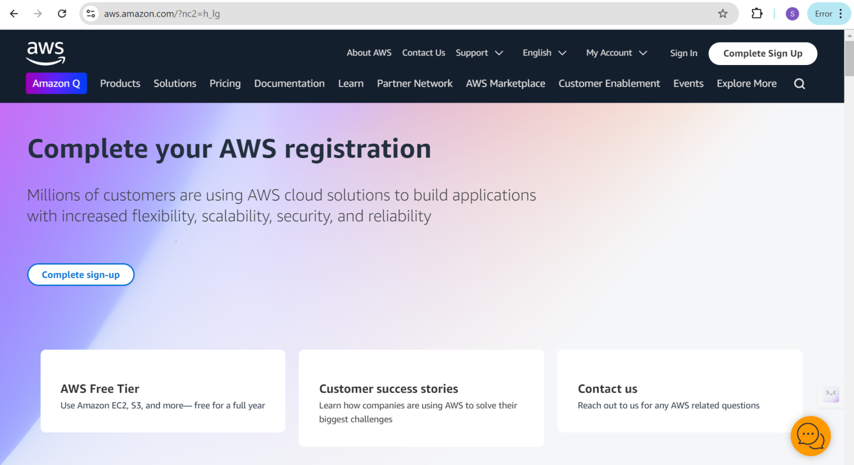

* **Activity 1.2: Log in to the AWS Management Console**
  + After setti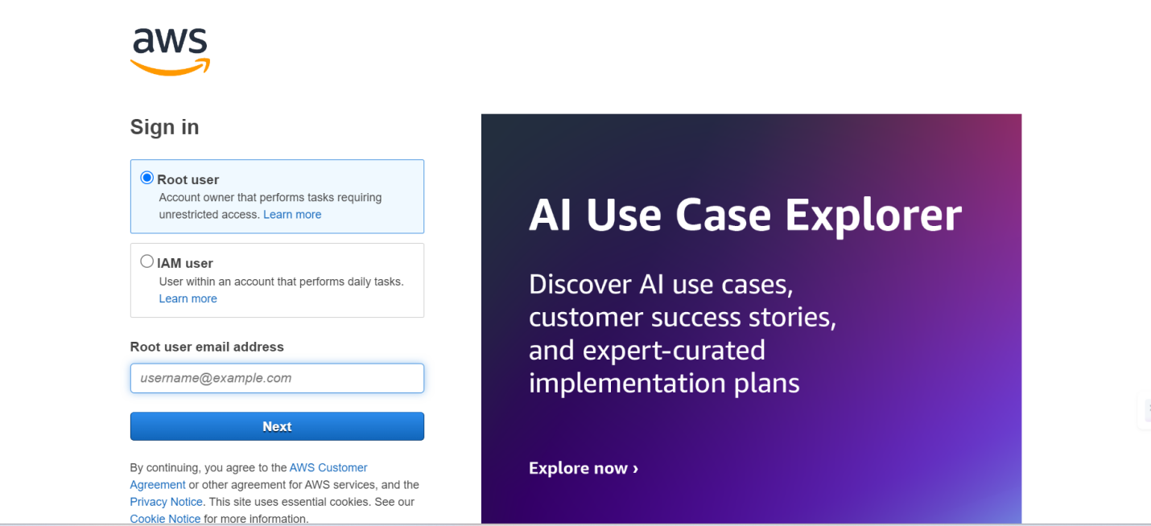ng up your account, log in to the [AWS Management Console](https://aws.amazon.com/console/).

**Milestone 2: S3 Setup**

* **Activity 2.1 : Create a bucket** 
  + Go to S3 Service

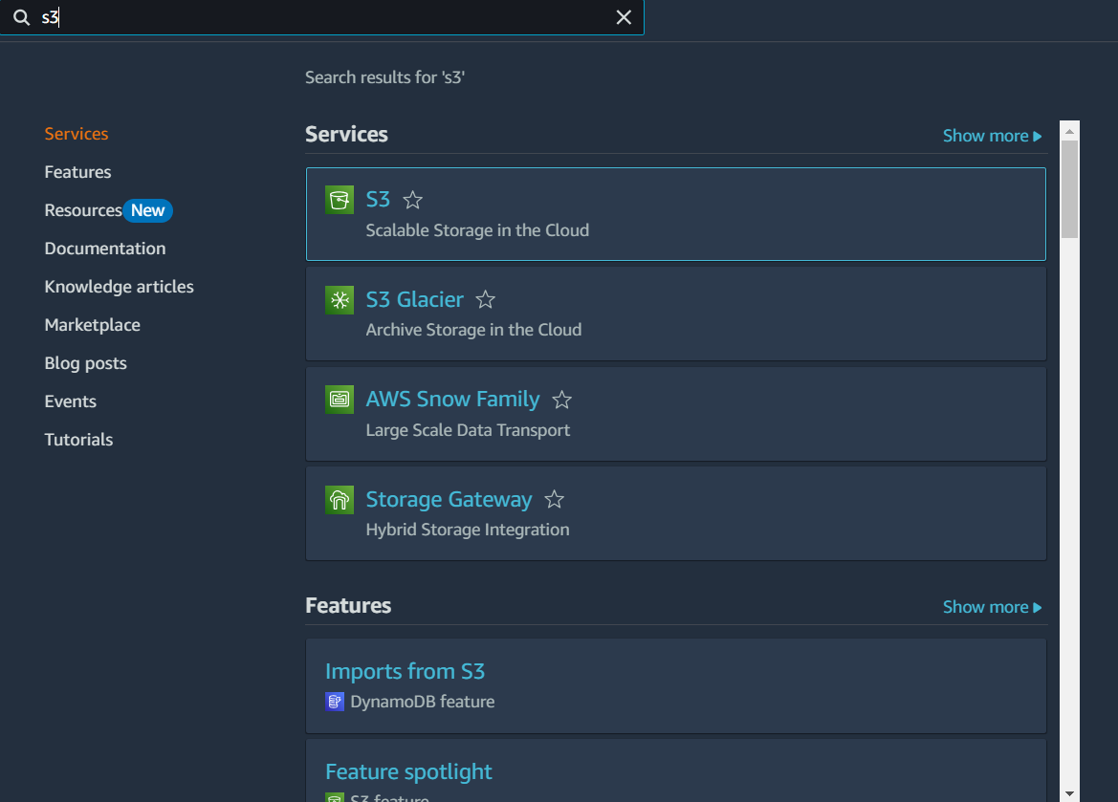

* + Click on **Create bucket**.

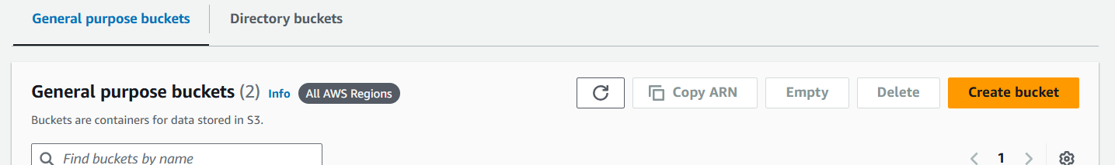

* + Enter a unique Bucket name (e.g., furniture-images-bucket).

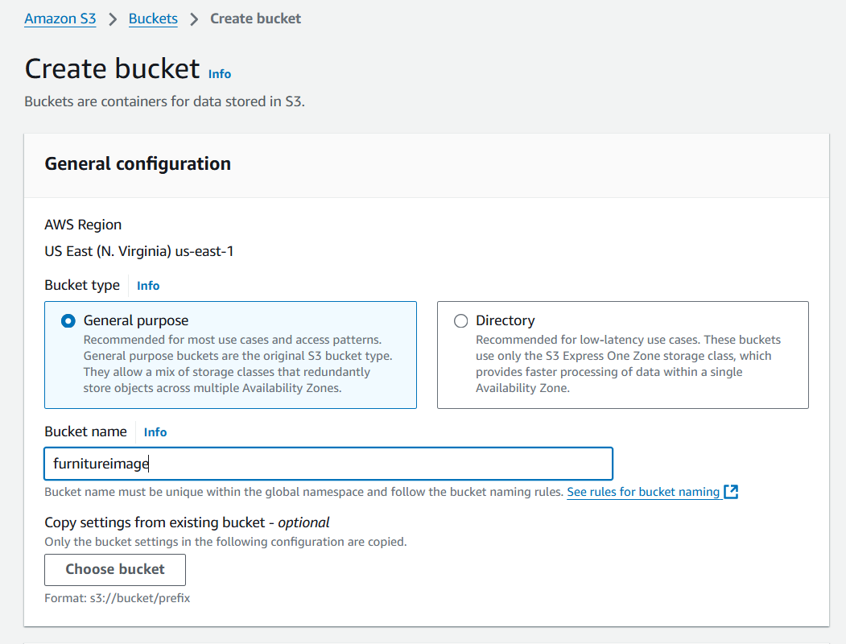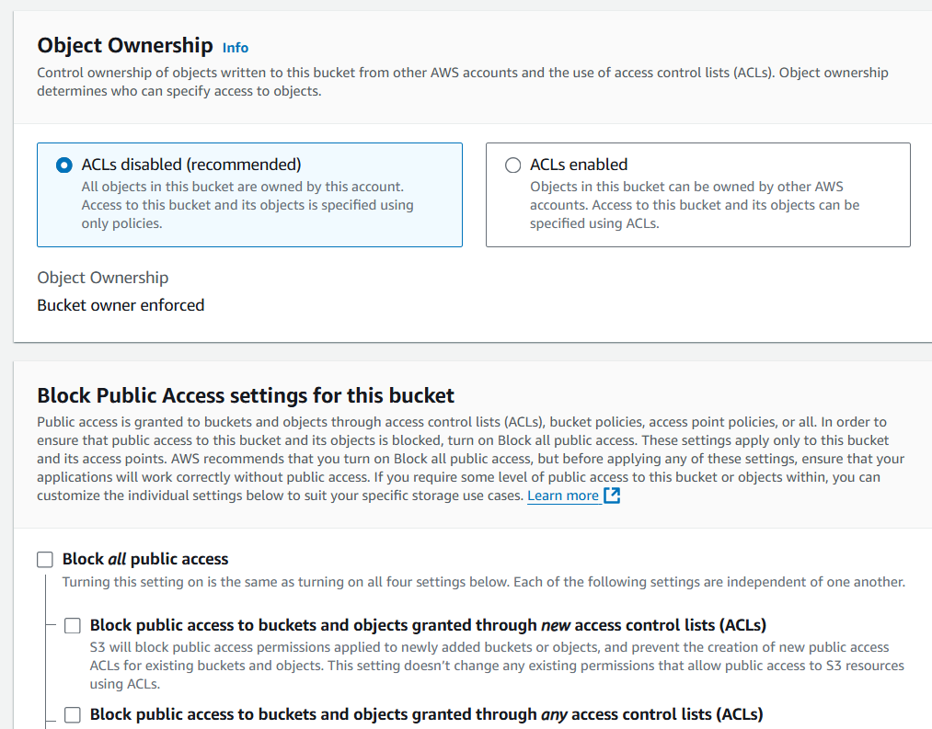

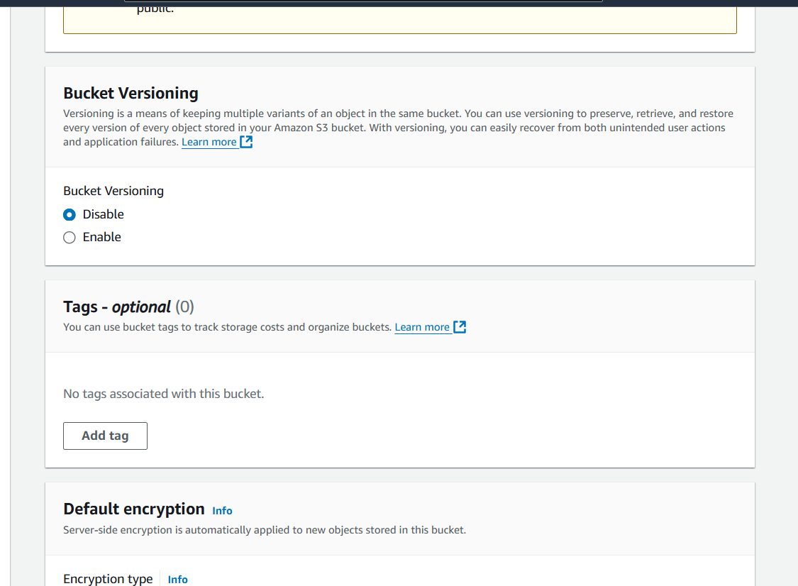

* + Click **Create bucket**.

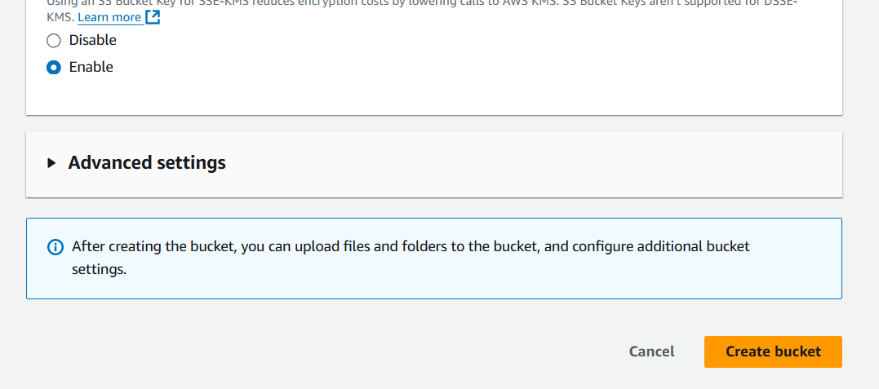

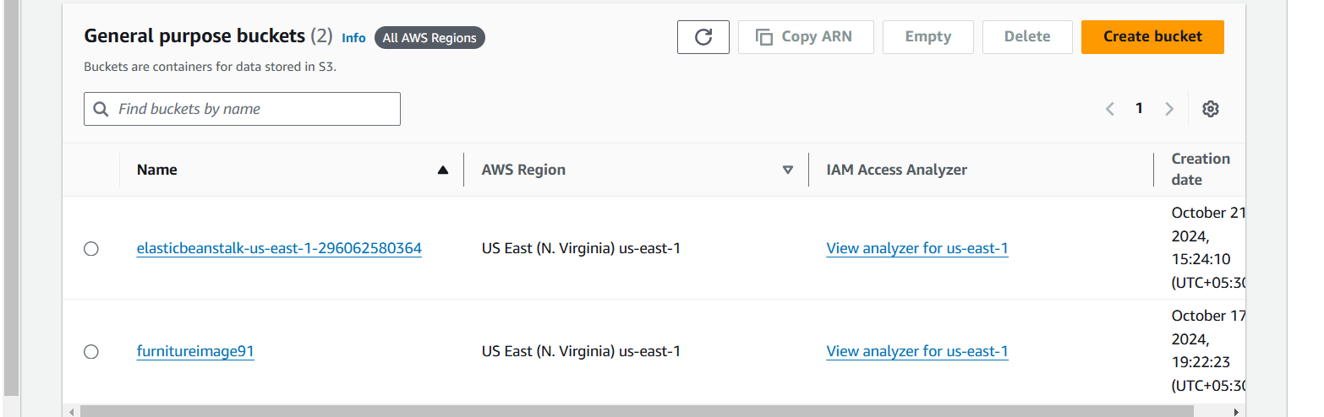

* **Activity 2.2 : Upload Furniture Images**
  + Go to Your Bucket

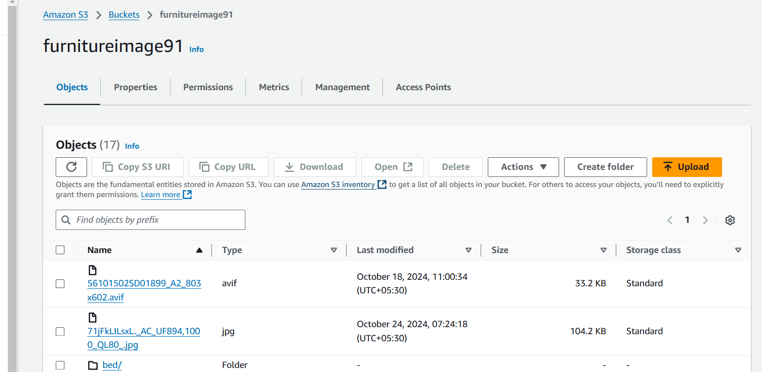

* + Click on the **Upload** button.

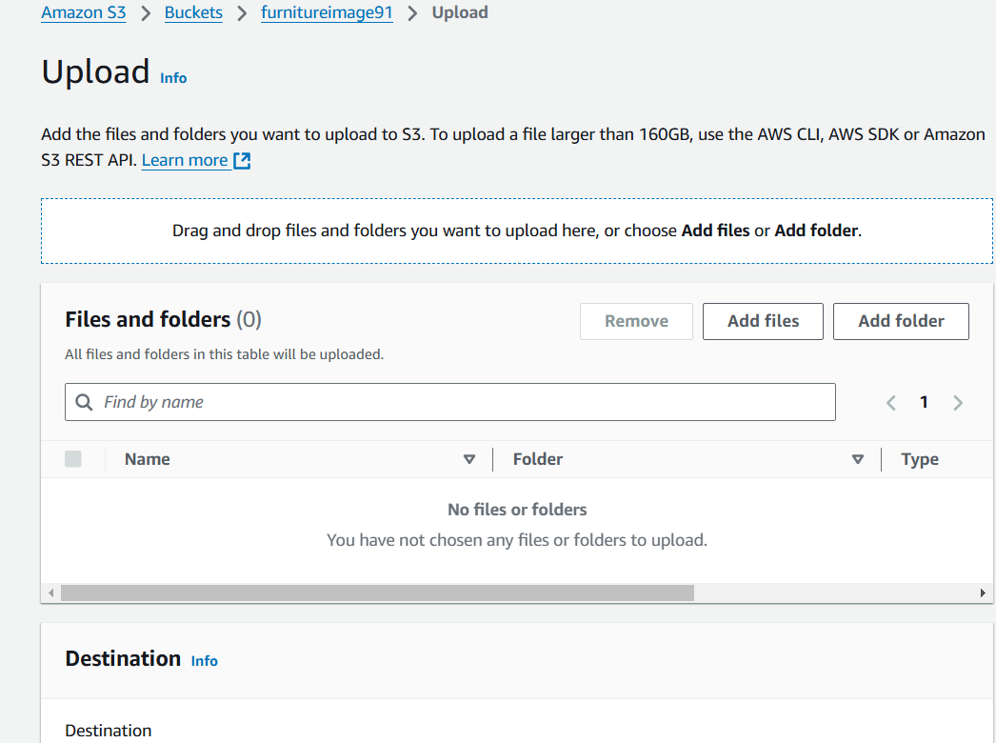

* + Drag and drop furniture images or select them from your local computer.

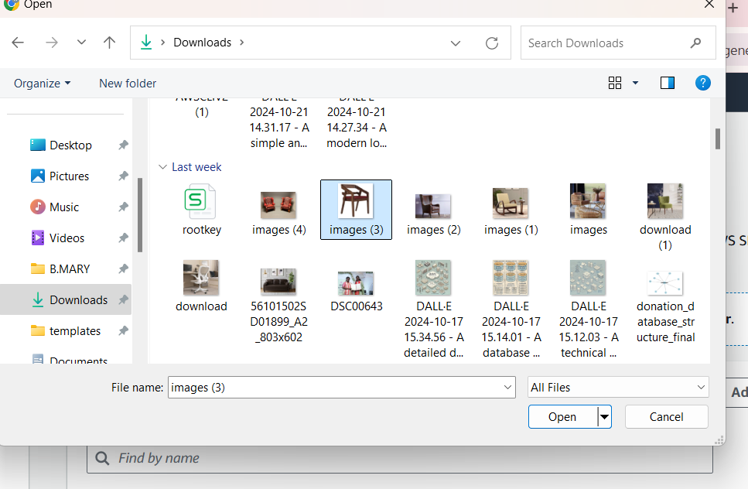

* + Click **Upload**.

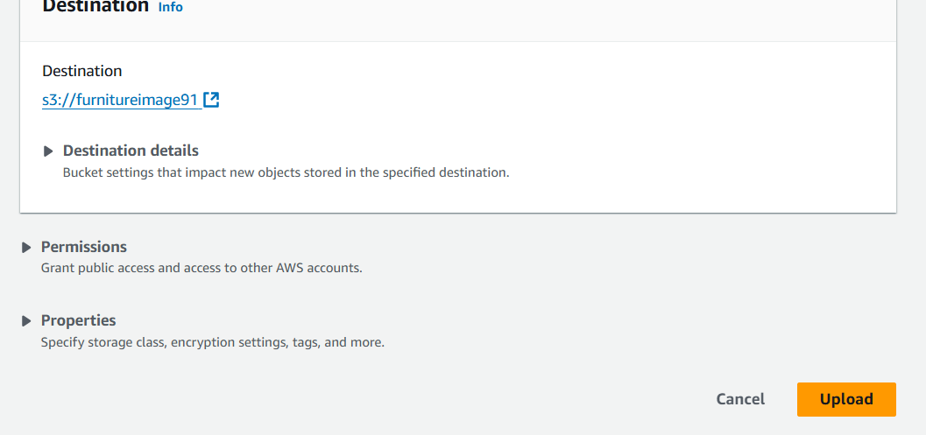

**Milestone 3: DynamoDB Database Creation and Setup**

* **Activity 3.1:Navigate to the DynamoDB**
  + In the AWS Console, navigate to DynamoDB and click on create tables.

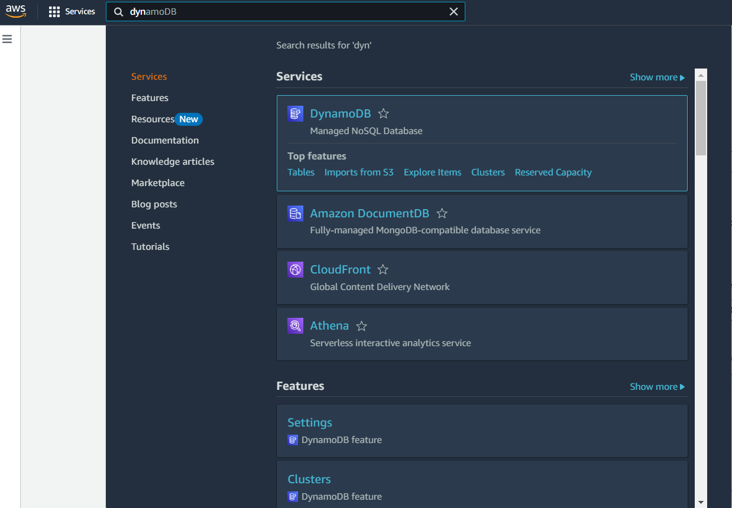

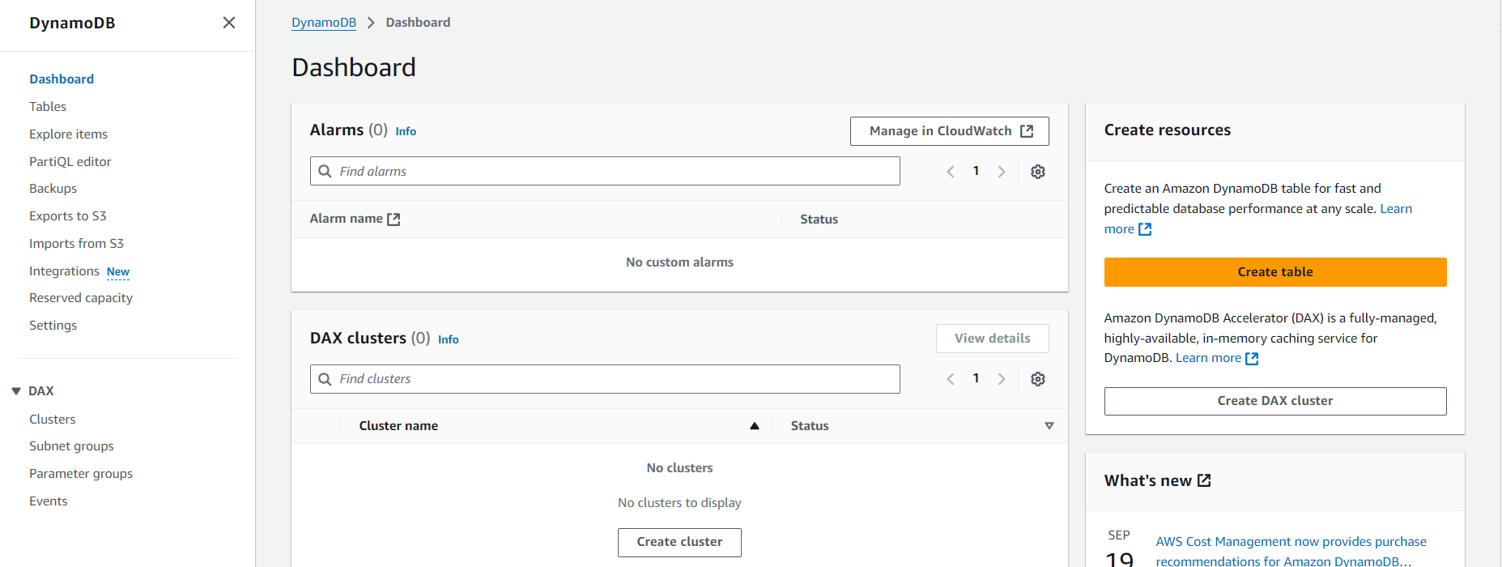

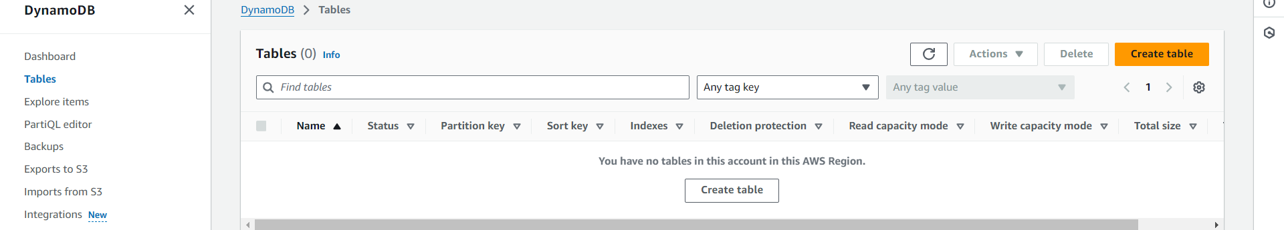

* **Activity 3.2:Create a DynamoDB table for storing furniture details .**
  + Create UsersTable with partition key “Item id” with type String.

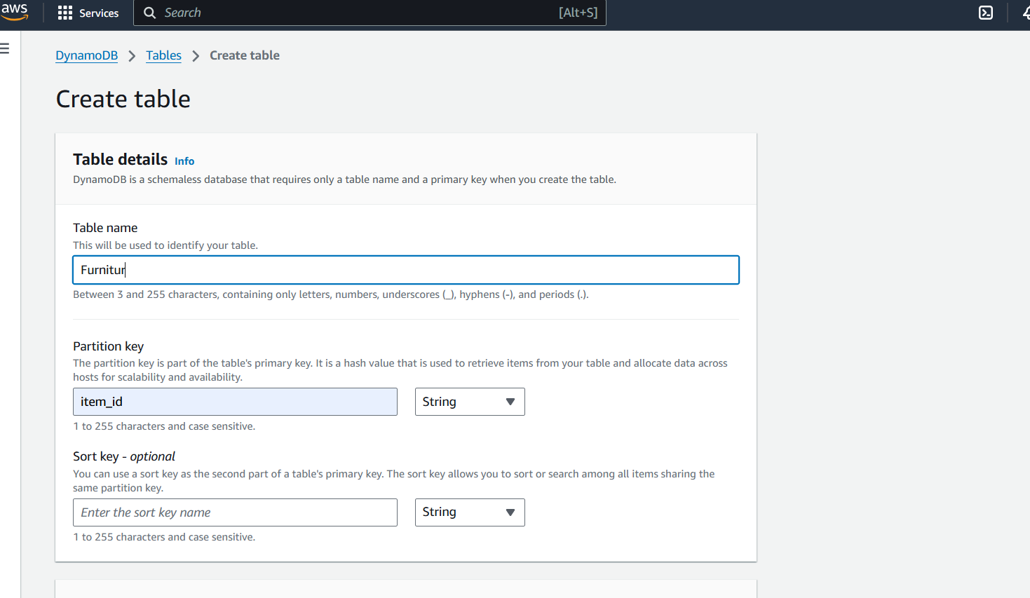

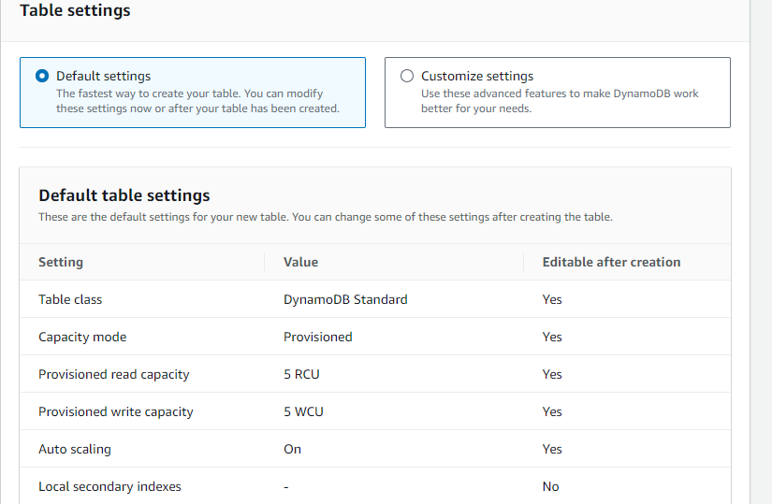

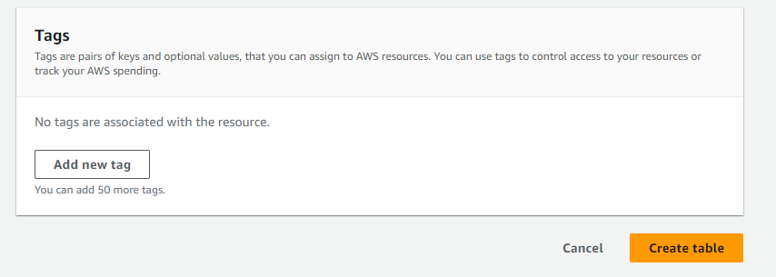

* + Follow the same steps to create customer_info with email as the primary key.

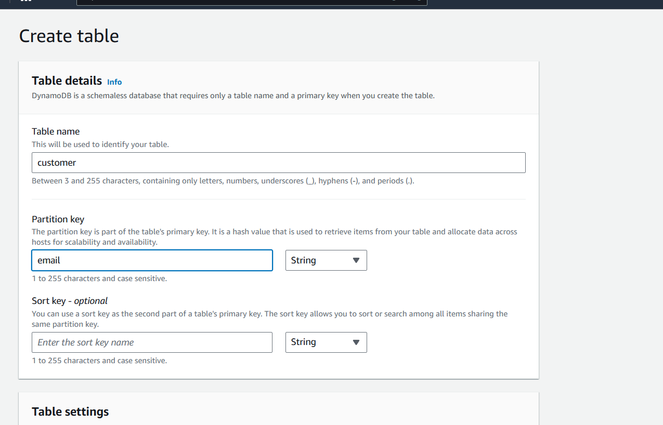





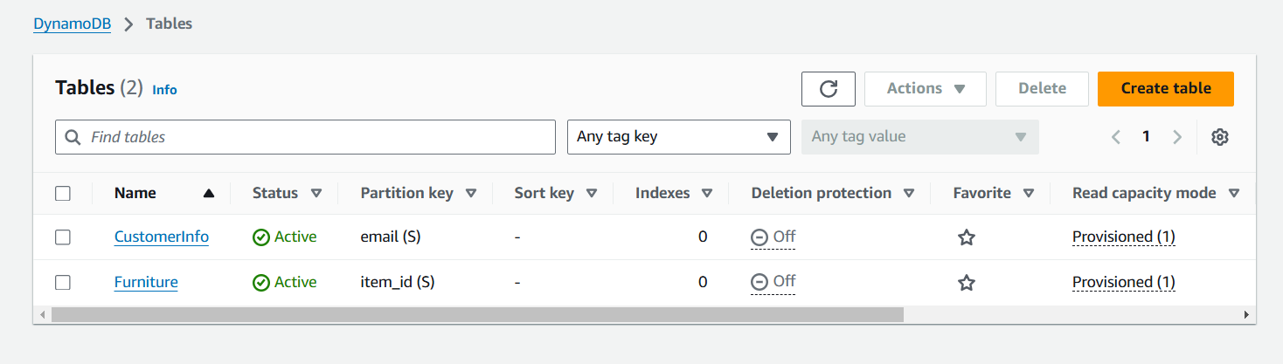

* **Activity 3.3 : Integrating DynamoDB With S3**
  + Once the table is created, go to **Items** and click **Create item**

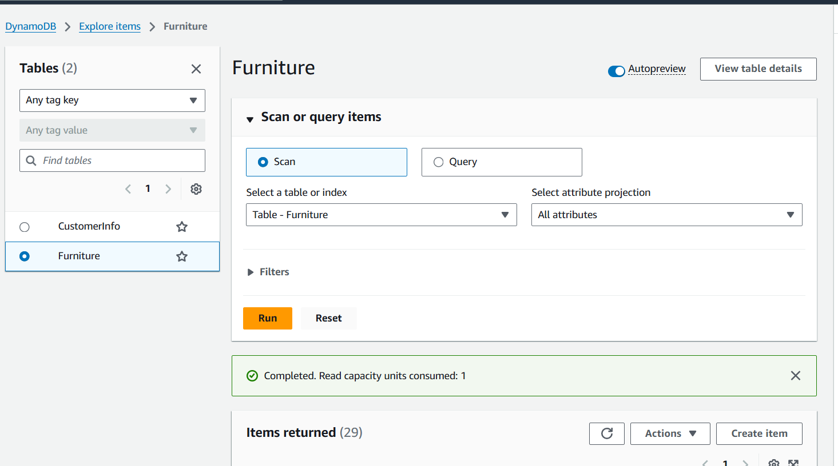

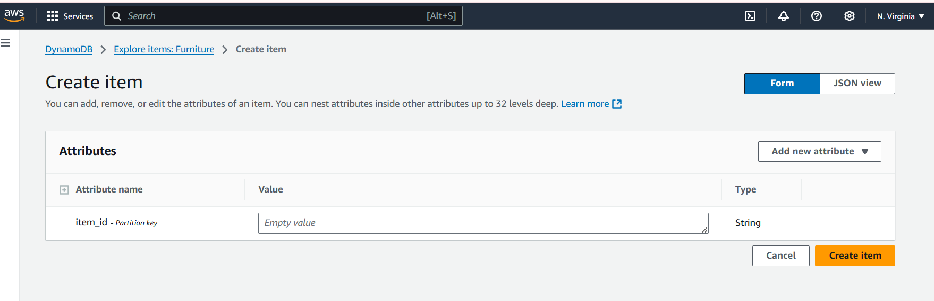

* + Add your metadata, such as
  + For each furniture item, you can store:
  + **ImageID**: Unique identifier for each image (primary key).
  + **Name**: Name of the furniture item.
  + **Category**: Category of furniture (e.g., Sofa, Table).
  + **Price**: Price of the furniture.
  + **S3URL**: The S3 URL where the image is stored.

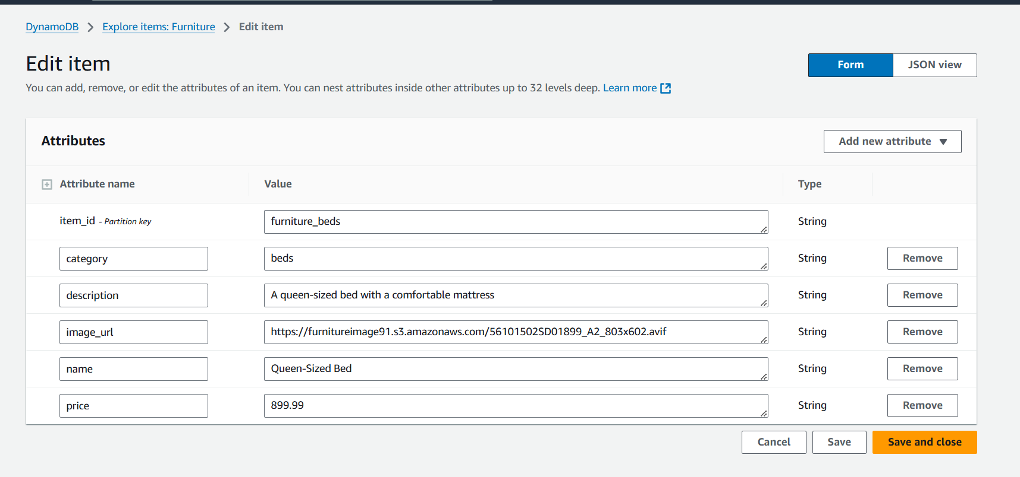

**Milestone 4: AWS Lambda and SES Setup**

* **Activity 4.1 : Create a lambda function** 
  + Choose the Lambda service from the AWS Management Console.

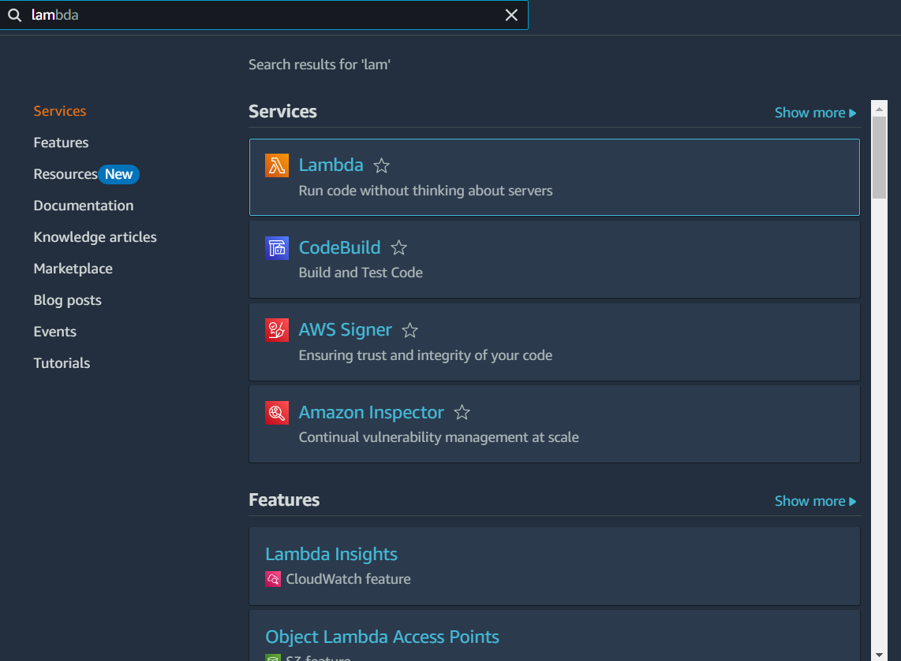

* + Click on **Create function**.

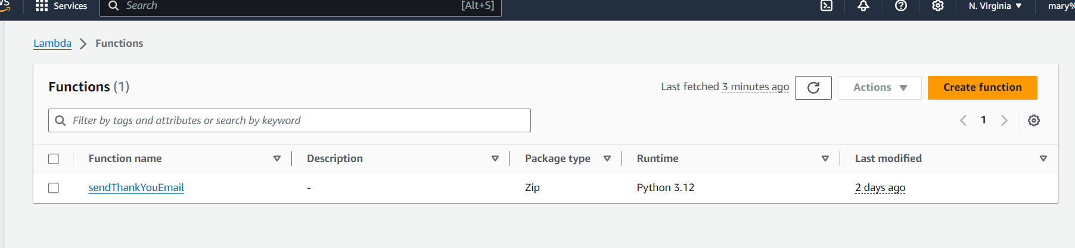

* + Choose **Author from scratch**.

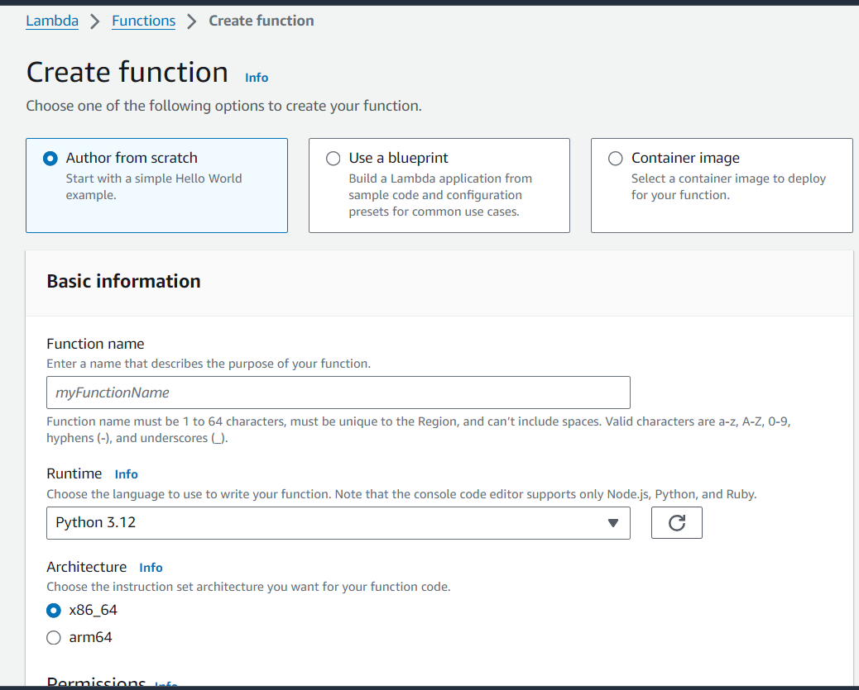

* + **Function name**: Enter a name
  + **Runtime**: Select a runtime (e.g., Python 3.x).
  + Click on create function.

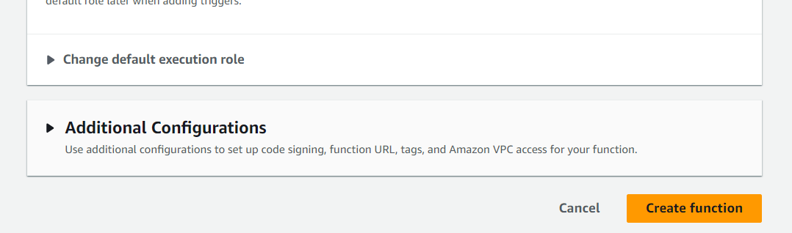

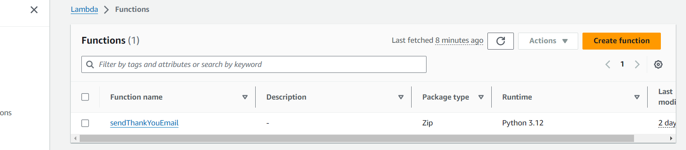

* **Activity 4.2: Set Up AWS SES:**
  + In the AWS Management Console, search for SES (Simple Email Service).

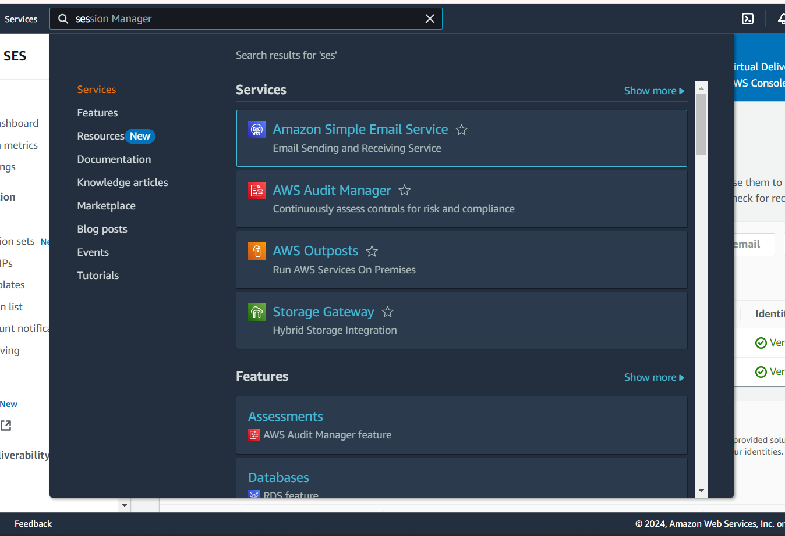

* + Click on the identity

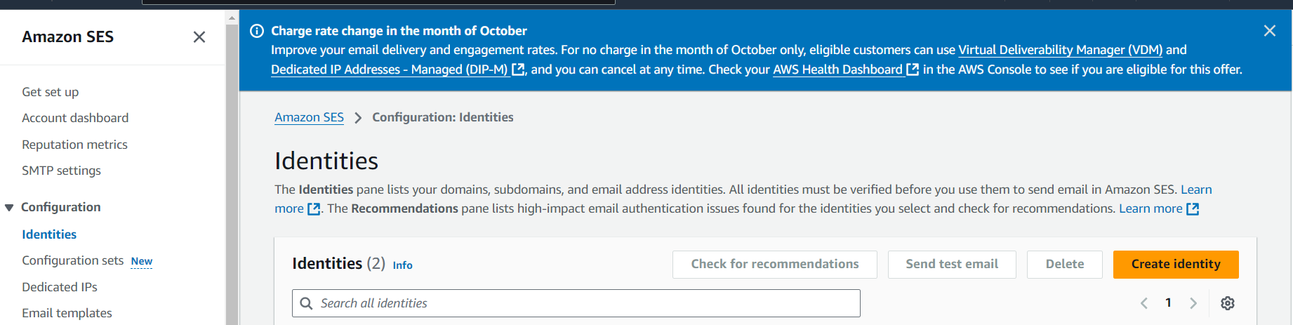

* + Click **Verify a New Email Address** and enter the sender email address you want to use.

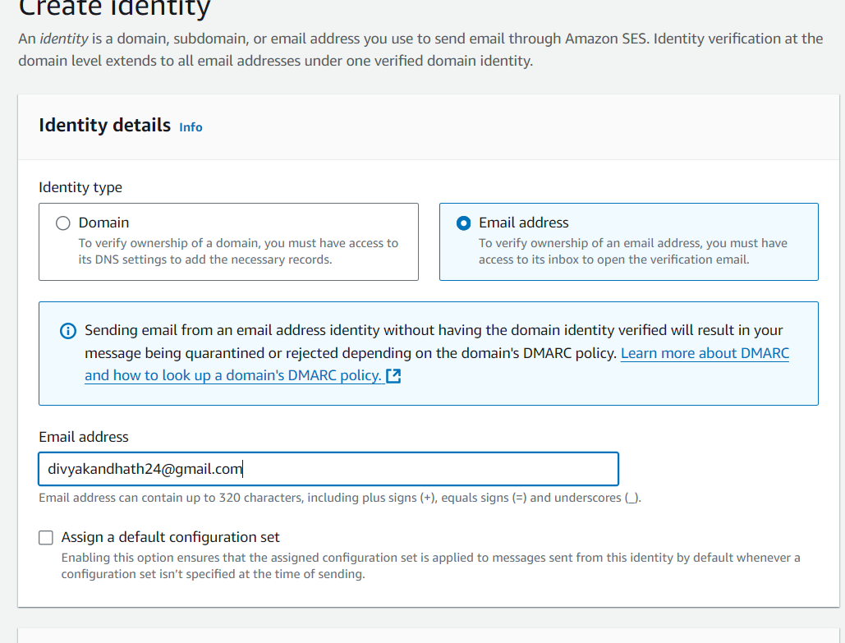

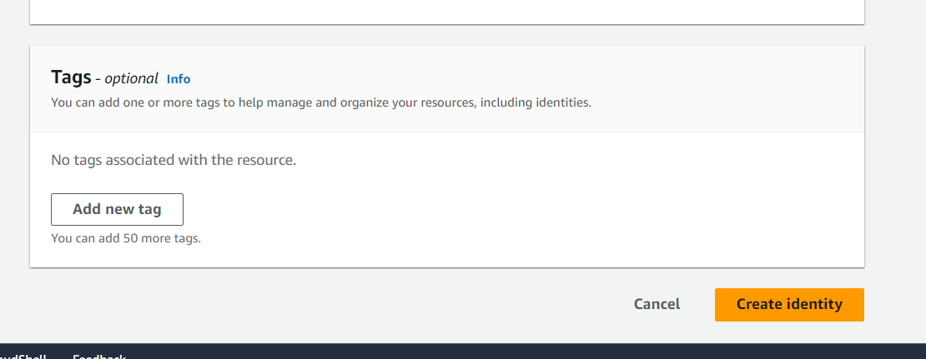

* + Click on create

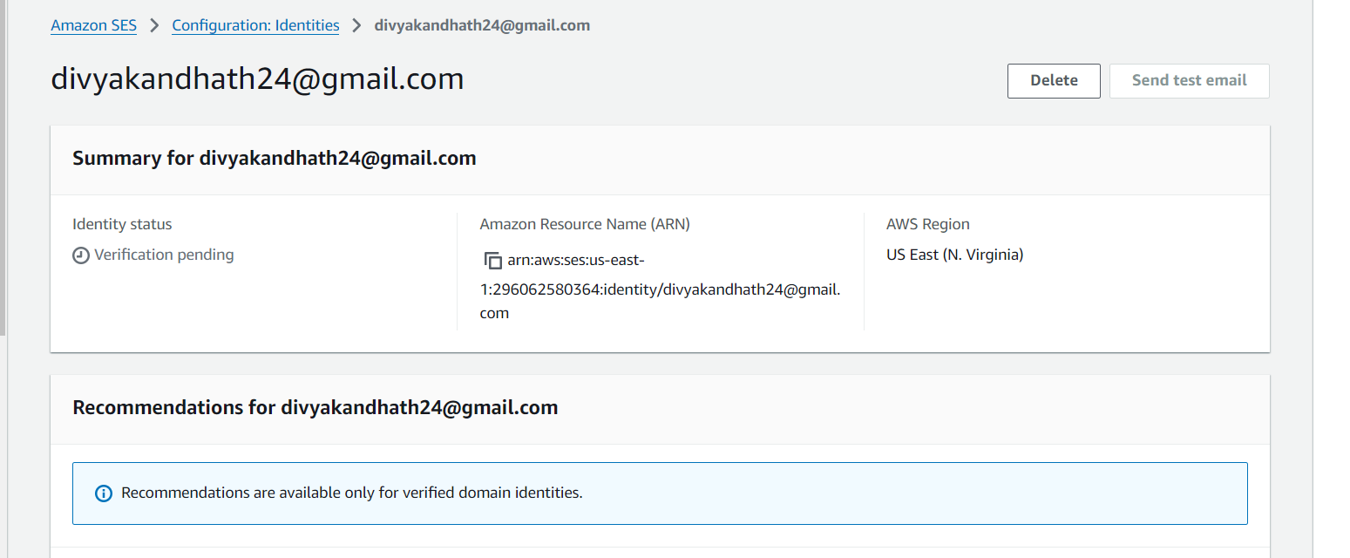

* + Check your email for a verification link and complete the verification process.

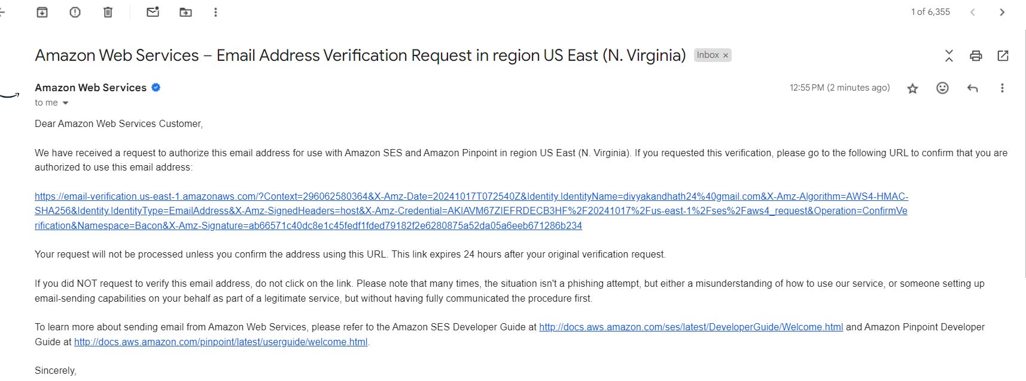

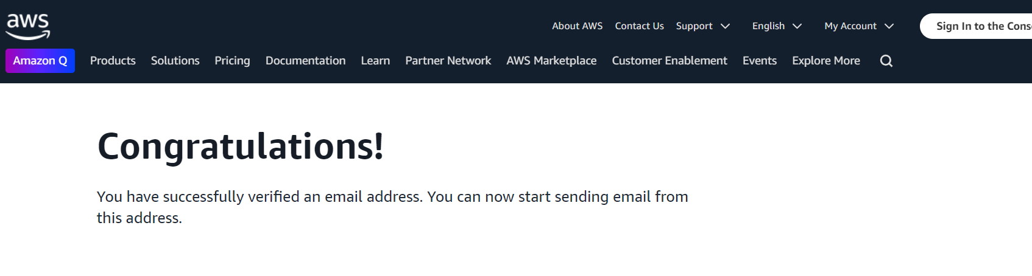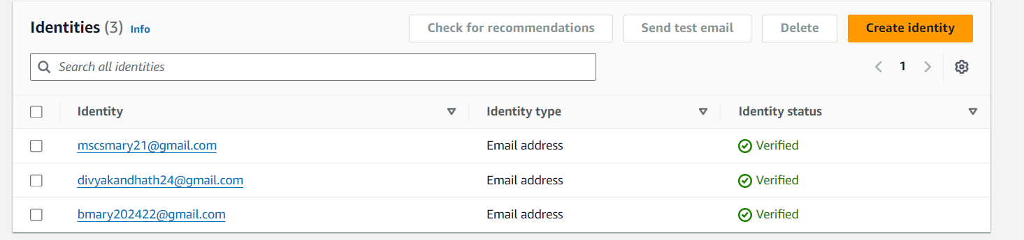

**Milestone 5:Backend Development and Application Setup**

* **Activity 5.1: Develop the backend using Flask**
  + File Explorer Structure

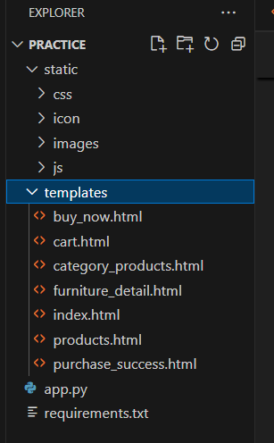

**Description of the code :**

* **Flask App Initialization**

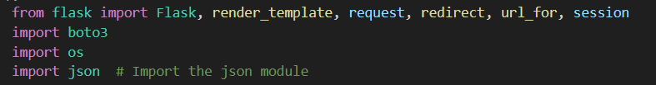



* Use **boto3** to connect to **DynamoDB and s3** for handling user adding furniture, customer info database operations and also mention

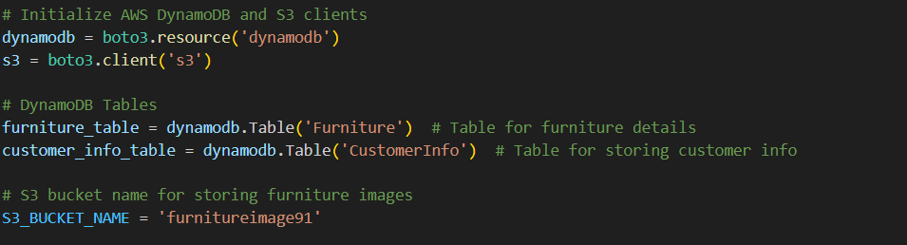

**Config.py:**

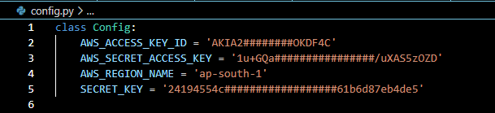  
 **Description:** The Config class contains configuration settings for the MedTrack application, including AWS access credentials and the secret key for session management. These settings enable secure access to AWS services like DynamoDB and EC2 while ensuring the application’s overall security.

**Secret.py:**

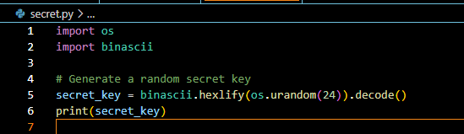

**Description:** This code generates a random secret key for use in applications by creating a random sequence of 24 bytes using os.urandom(24). The bytes are then converted to a hexadecimal string, ensuring a secure key suitable for cryptographic operations.

* **Routes for Web Pages**

1. **Index Page Route:**  
     
    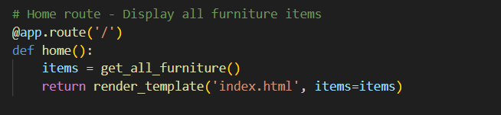

A route is defined for the home page ('/') that directly loads the main furniture catalog. When users visit the homepage, the index.html template is rendered, displaying featured furniture items, categories, and options to view detailed information about each item.

1. **Products Route:**

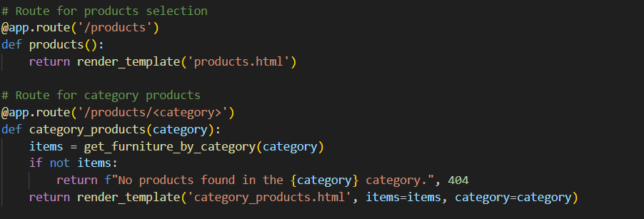

**Description:** A route is defined for the **products selection page** ('/products'). When users navigate to this route, the products.html template is rendered, displaying the available furniture items. This page allows users to browse through different furniture products, view product details, and make selections based on their preferences.

1. **Category Route:**

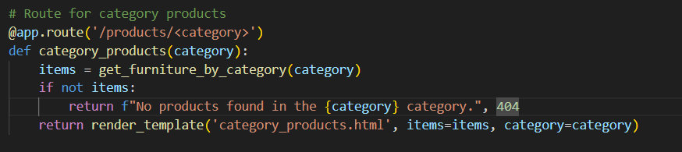

A route is defined for displaying products by category ('/products/<category>'). When users select a specific category of furniture, the route retrieves the relevant items from the database using the get_furniture_by_category(category) function. If no products are found for the given category, a message is displayed indicating no products are available, with an HTTP 404 error code. Otherwise, the category_products.html template is rendered, displaying the items in the selected category along with the category name.

1. **Furniture Detail route:**  
   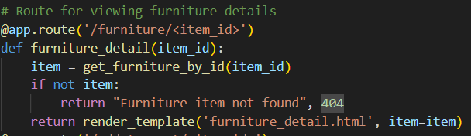**Description:** A route is defined for viewing detailed information about a specific furniture item ('/furniture/<item_id>'). When users select an item, the route retrieves the furniture details using the get_furniture_by_id(item_id) function. If the item does not exist, a message is displayed indicating that the furniture item is not found, with an HTTP 404 error code. Otherwise, the furniture_detail.html template is rendered, displaying the full details of the selected furniture item, such as its name, description, price, and images.
2. **Cart Route:**

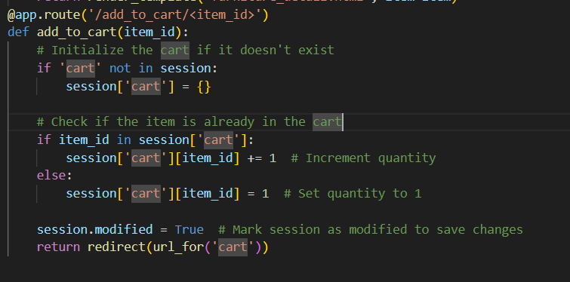

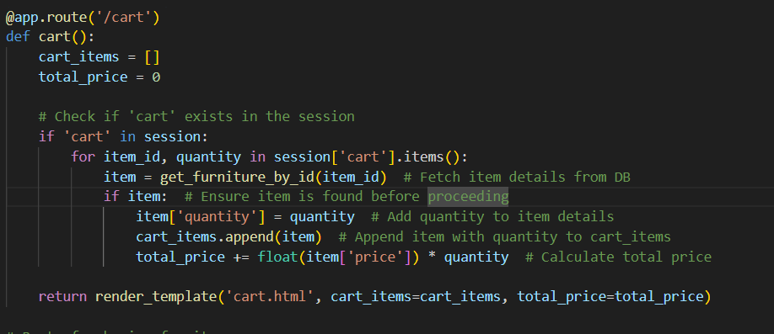

**Description:** A route is defined for adding a furniture item to the shopping cart ('/add_to_cart/<item_id>'). When users choose to add a specific item to their cart, the route checks if the cart already exists in the session. If not, it initializes an empty cart. The route then verifies if the item is already in the cart: if it is, the item’s quantity is incremented; if not, the item is added to the cart with a quantity of one. After updating the cart, the session is marked as modified to ensure changes are saved. Finally, the user is redirected to the cart page to view their updated selections.

1. **Buy now Route:**

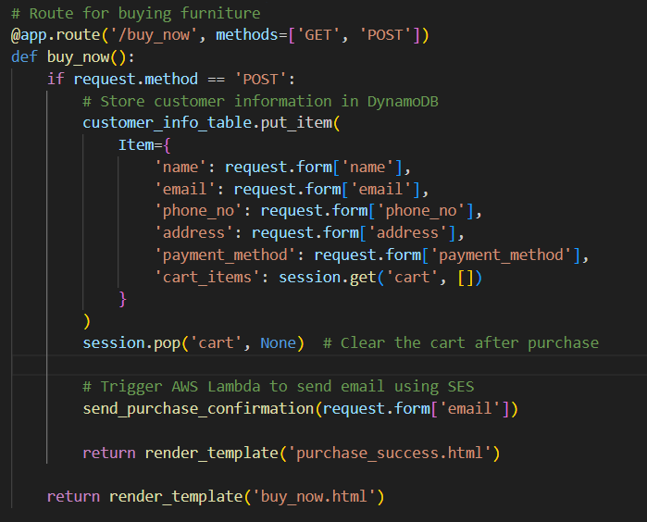

**Description:** A route is defined for processing furniture purchases ('/buy_now') that accepts both GET and POST requests. When users submit their purchase information via a POST request, the application stores the customer’s details—such as name, email, phone number, address, and payment method—into a DynamoDB table using the put_item method. The current items in the cart are also included in this entry. After the purchase is processed, the cart is cleared from the session to reflect that the items have been purchased. Additionally, an AWS Lambda function is triggered to send a purchase confirmation email using Amazon SES to the customer. Upon successful processing, the user is redirected to a confirmation page rendered by the purchase_success.html template. If the request method is GET, the buy_now.html template is rendered to present the purchase form to the user.

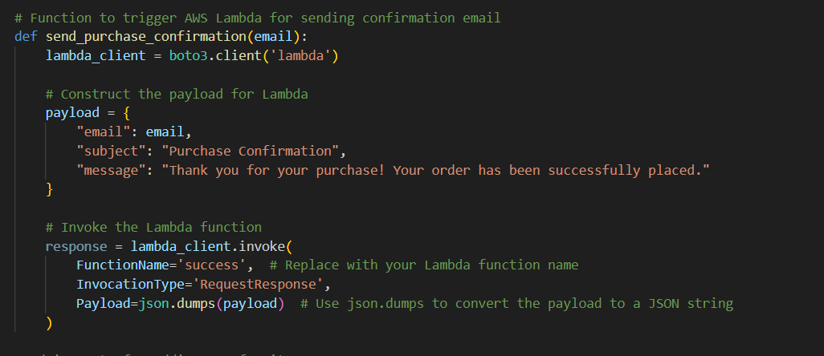

Lambda Function to trigger ses to generate thank you mail:

**Deployment Code:**

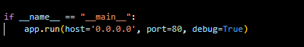

### Description:

### This code snippet serves as the main entry point for the Flask application. When the script is executed directly, it starts the Flask development server in debug mode, allowing for live reloading and detailed error messages, which is useful for development and testing.

**Milestone 6: IAM Role Setup**

* **Activity 6.1:Create IAM Role.**
  + In the AWS Console, go to IAM and create a new IAM Role for EC2 to interact with DynamoDB and SNS.

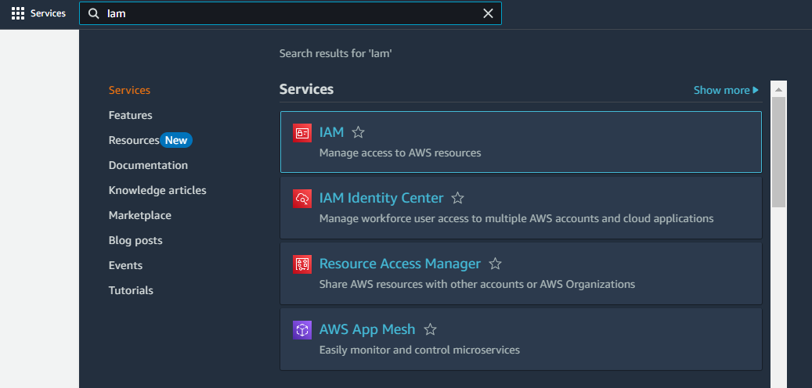

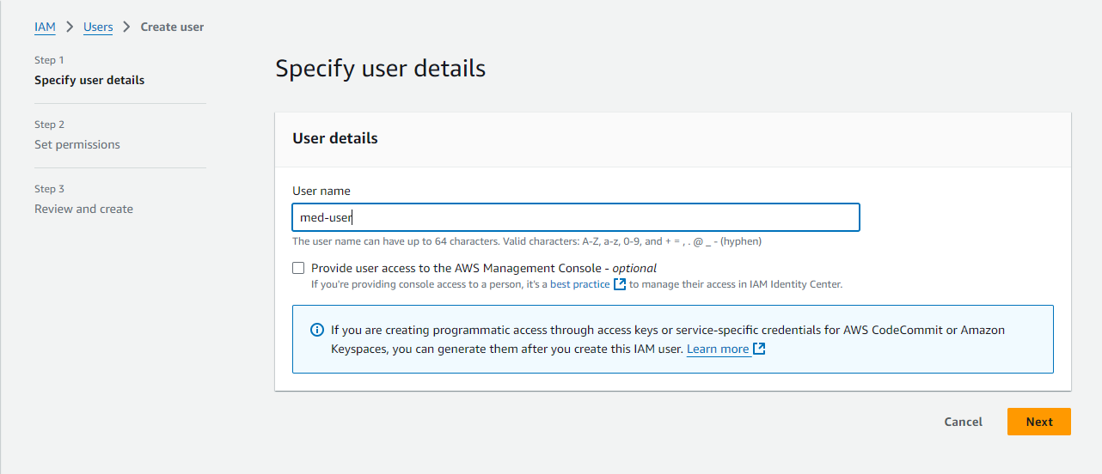

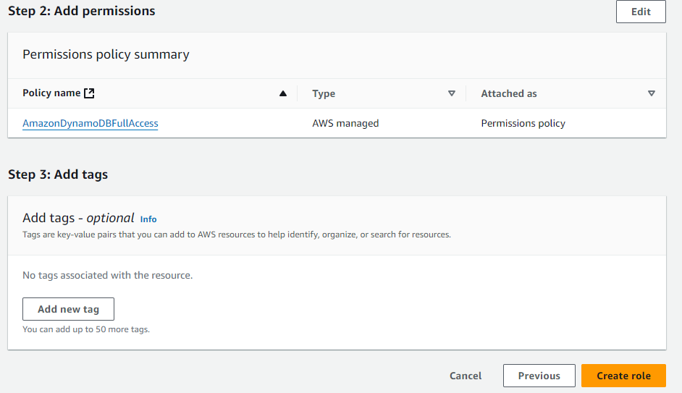

* **Activity 6.2: Attach Policies.**

Attach the following policies to the role:

* AmazonDynamoDBFullAccess: Allows EC2 to perform read/write operations on DynamoDB.

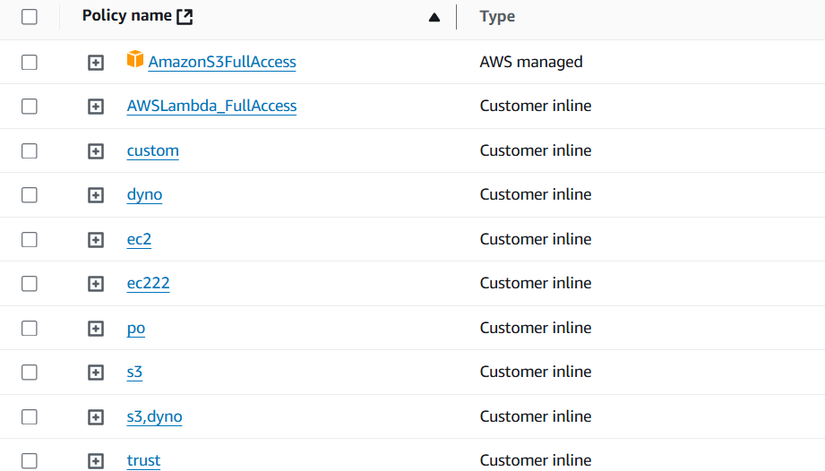

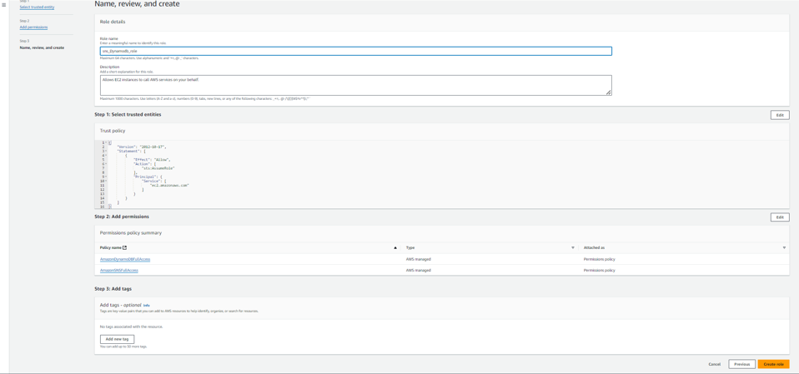

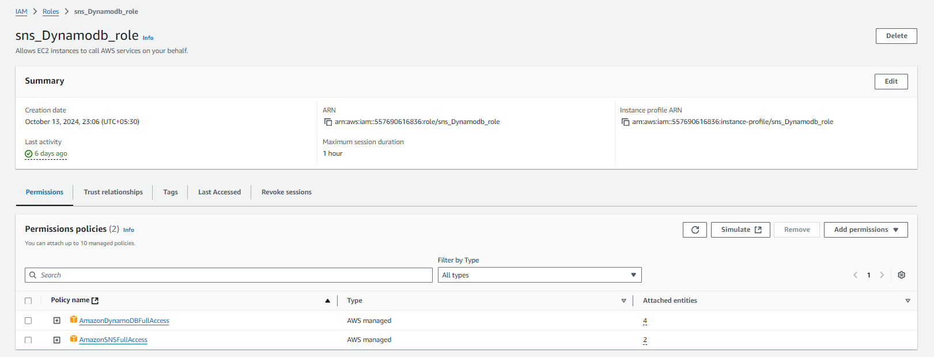

**Milestone 7: EC2 Instance Setup**

* + Choose a Linux-based EC2 instance from the AWS Console to host the Medtrack application.
* **Activity 7.1: Launch an EC2 instance to host the Flask application.**
* **Launch EC2 Instance**
  + In the AWS Console, navigate to EC2 and launch a new instance.

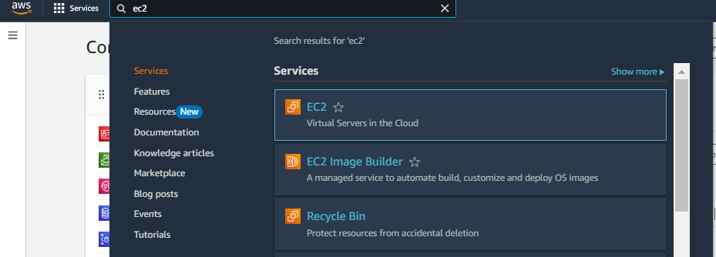

* Click on Launch instance to launch EC2 instance

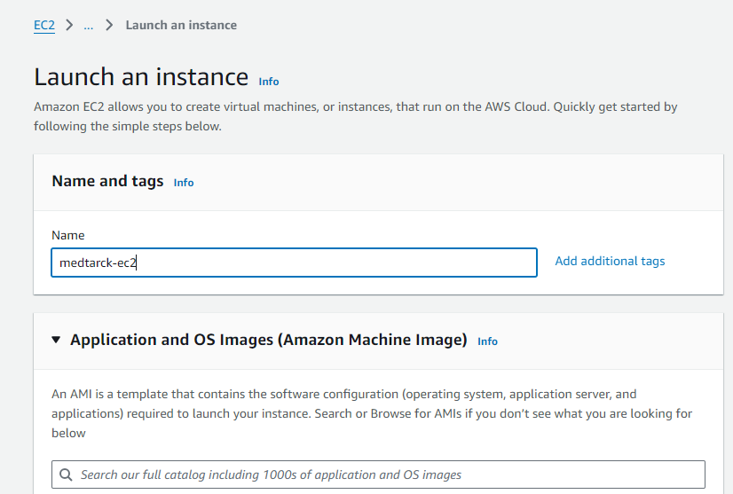

* Choose Amazon Linux 2 or Ubuntu as the AMI and t2.micro as the instance type (free-tier eligible).

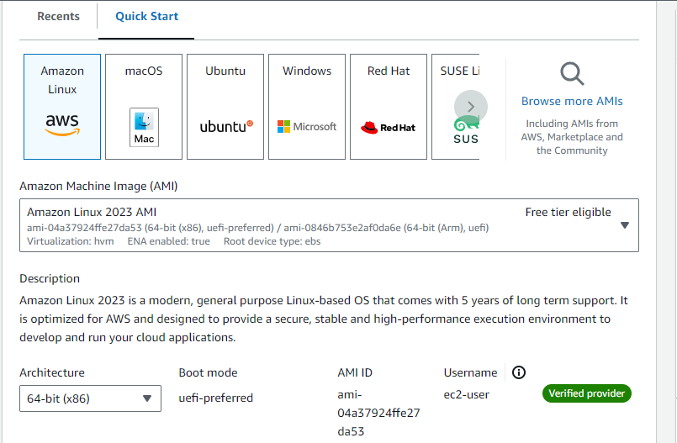

* Create and download the key pair for Server access.

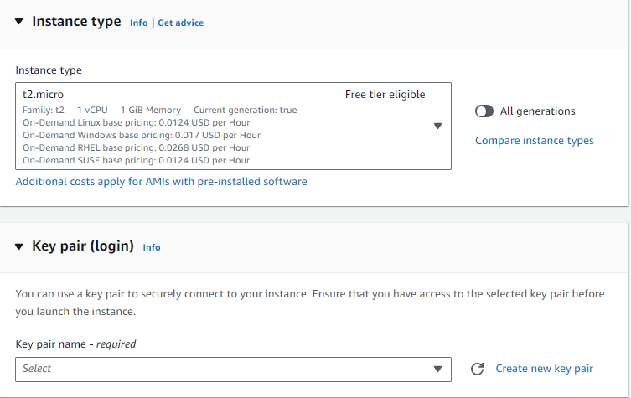

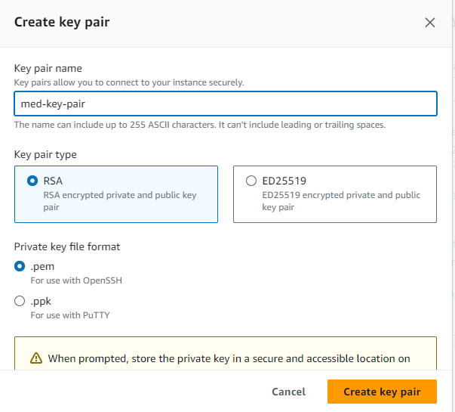

* **Activity 6.2:Configure security groups for HTTP, and SSH access.**

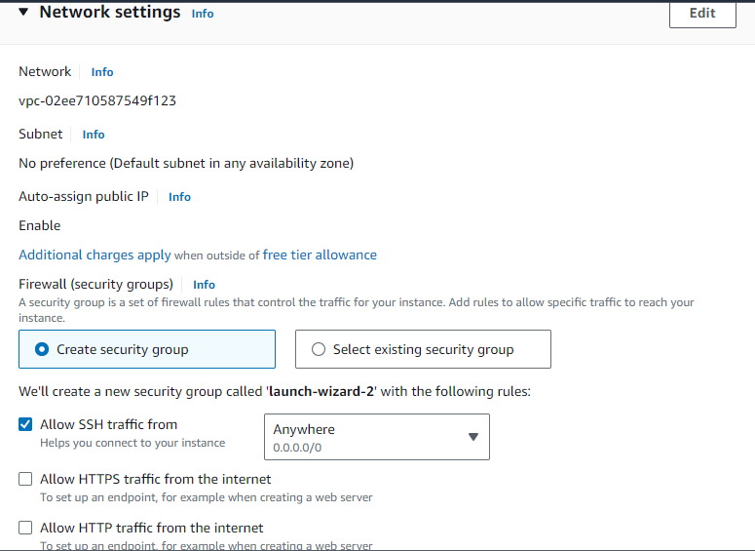

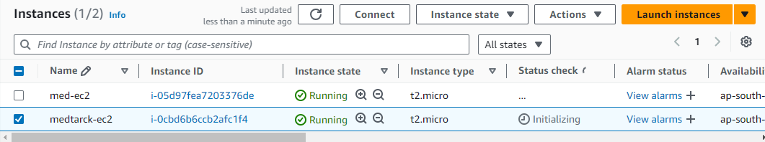

**Setting up Inbound and Outbound rules**

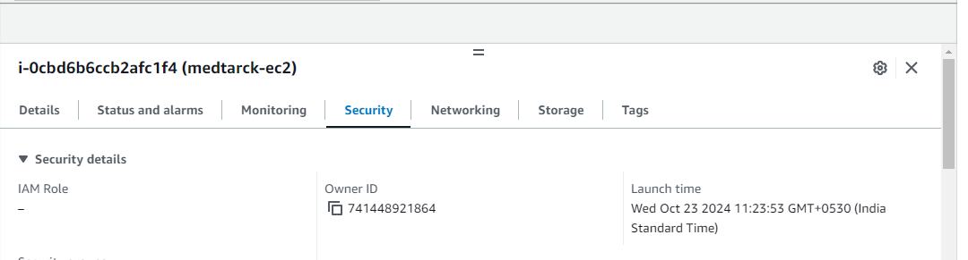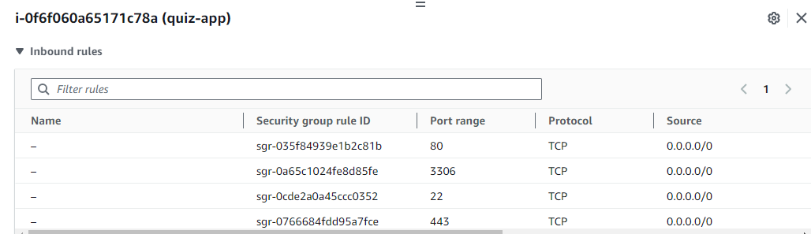

* Add Type : HTTP > Source : Anywhere
* Add Type : HTTPS > Source : Anywhere

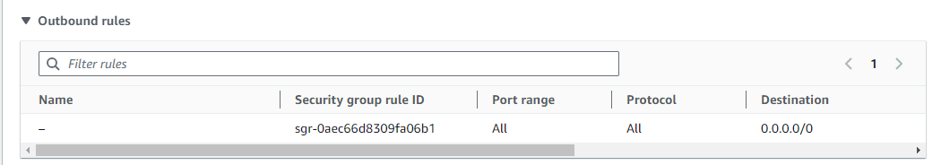

**Milestone 8: Testing and Deployment**

* **Activity 8.1: Deploy to EC2**

1. Connect EC2 terminal.
2. Set up any necessary environment variables, including database connection strings.
3. Configure the web server to serve your application.
4. Start your application and ensure it's accessible via the EC2 instance's public IP or domain.

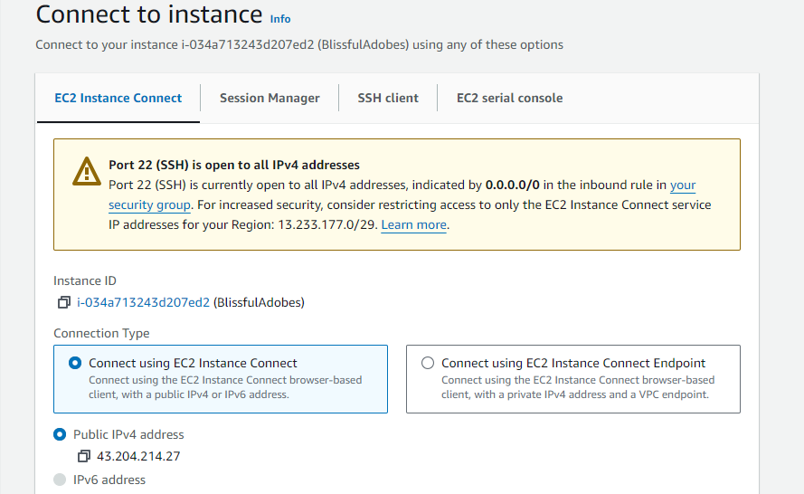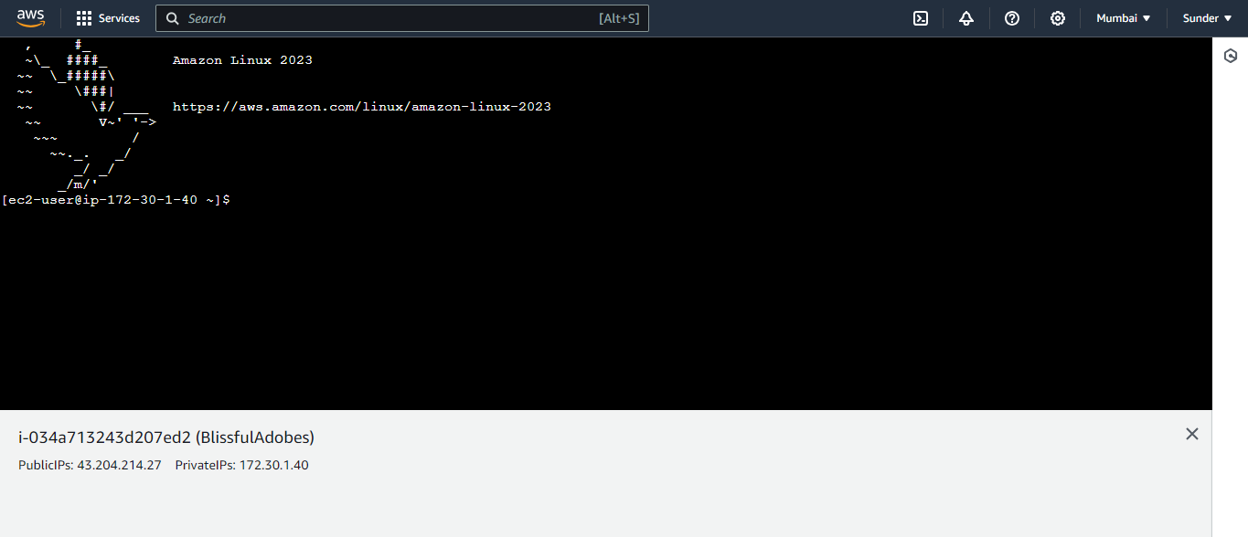

1. Run the below commands on ec2 terminal
2. sudo yum update -y
3. sudo yum install python3 -y
4. sudo pip3 install virtualenv
5. python3 -m venv venv.
6. source venv/bin/activate
7. pip install flask
8. git clone <https://github.com/Mary9140/Furnish-Fusion>
9. cd your-flask-app
10. Python3 app.py

* **Functional Testing**
  + Test the app.py application for functionality, including database interactions and frontend features.
  + Run the Flask app **python3 app.py**
  + It will give you the link

**Access the website through:**

**PublicIPs:** [**http:13.164.83.44:5000**](http://13.164.83.44:5000)

* **Activity 8.2: Deployment**
  + Deploy the application in a production environment, ensuring high availability and performance.

Click on the link above and it will take you to the webpage:

**Milestone 9: Testing and Deployment**

* **Activity 9.1: Functional Testing**
  + Test the furniture fushion application for functionality, including database interactions and frontend features.

**Index Page:**

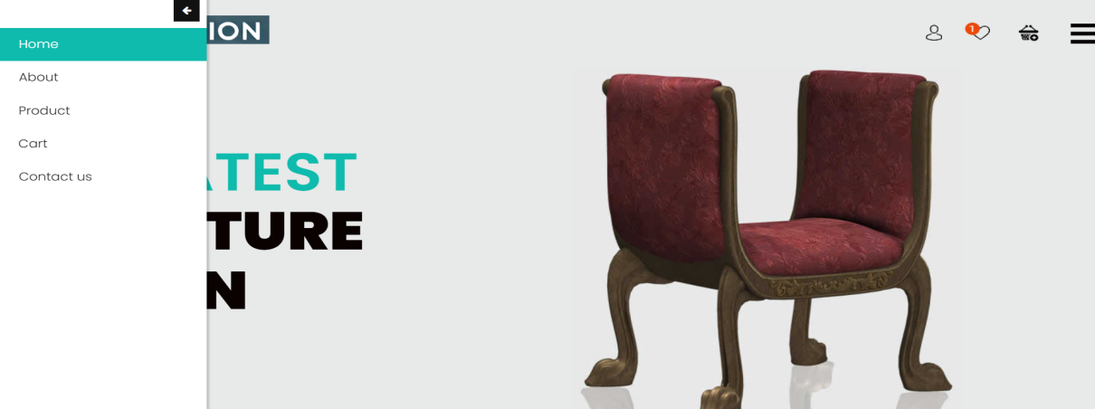

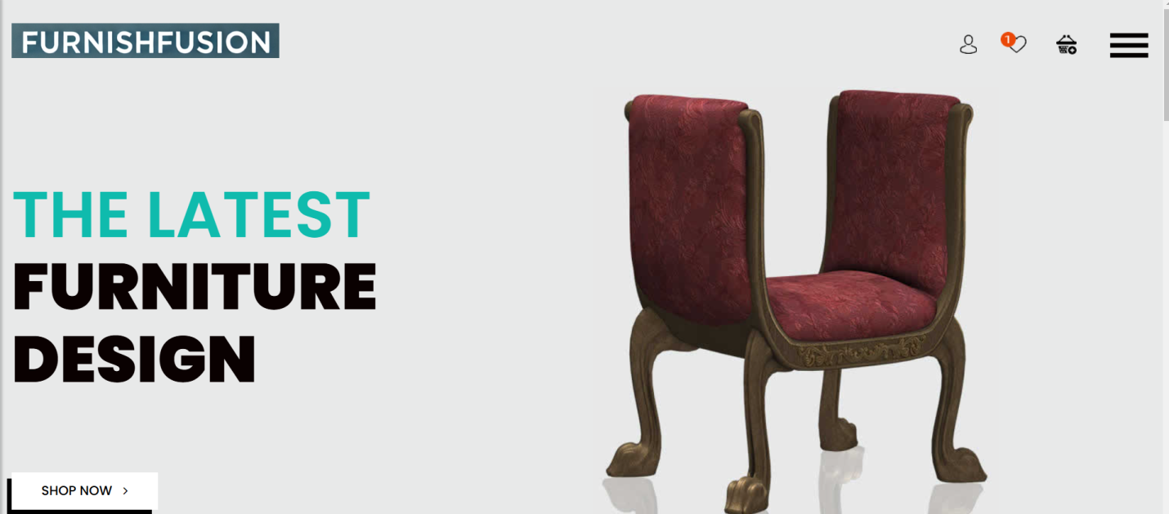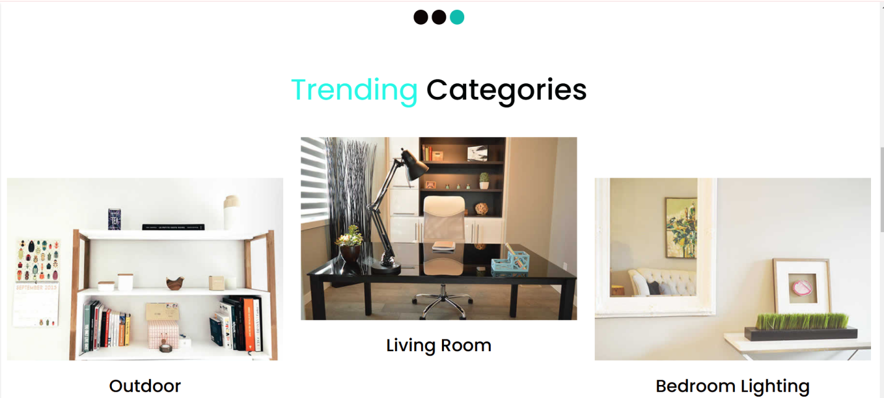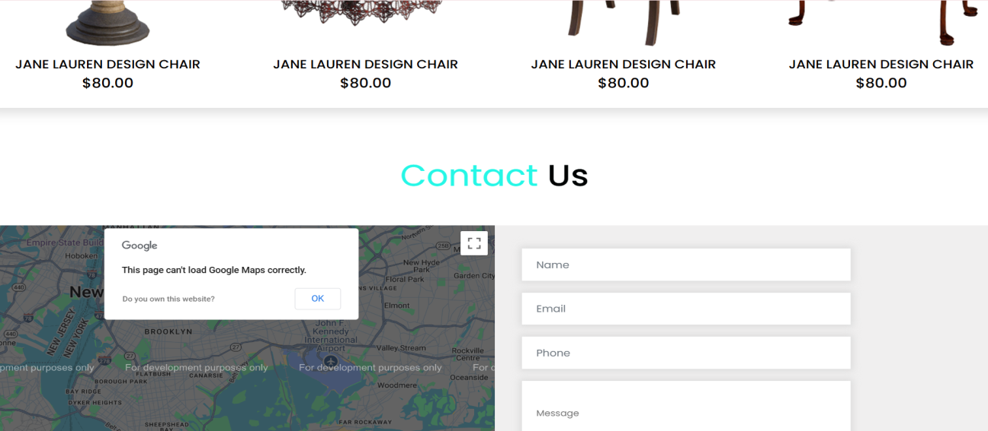

**Products Page:**

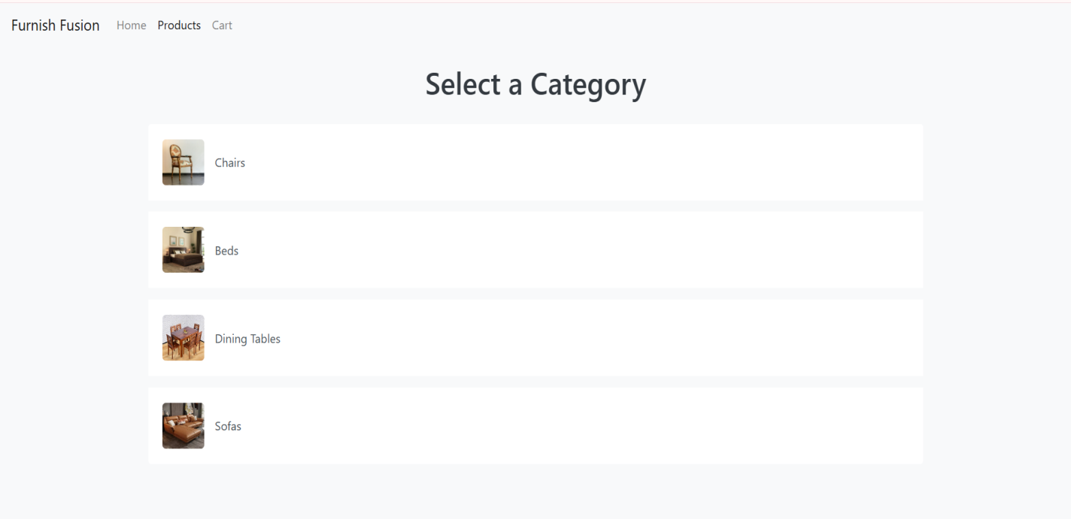

**Different category Page:**

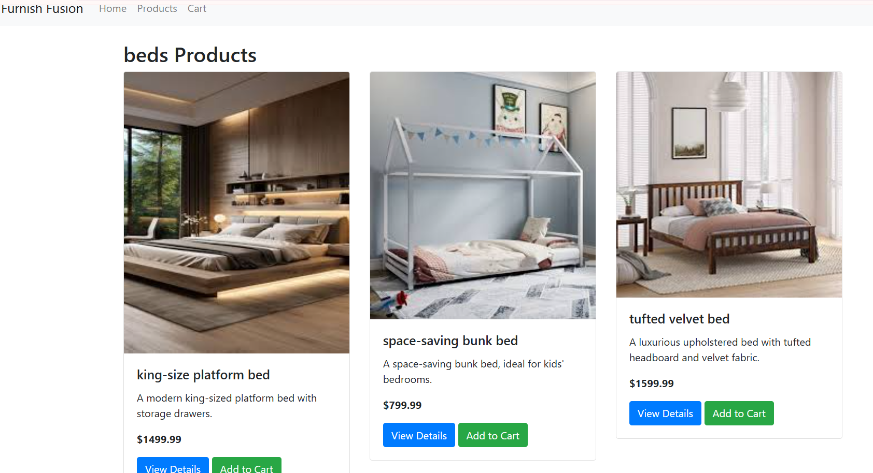

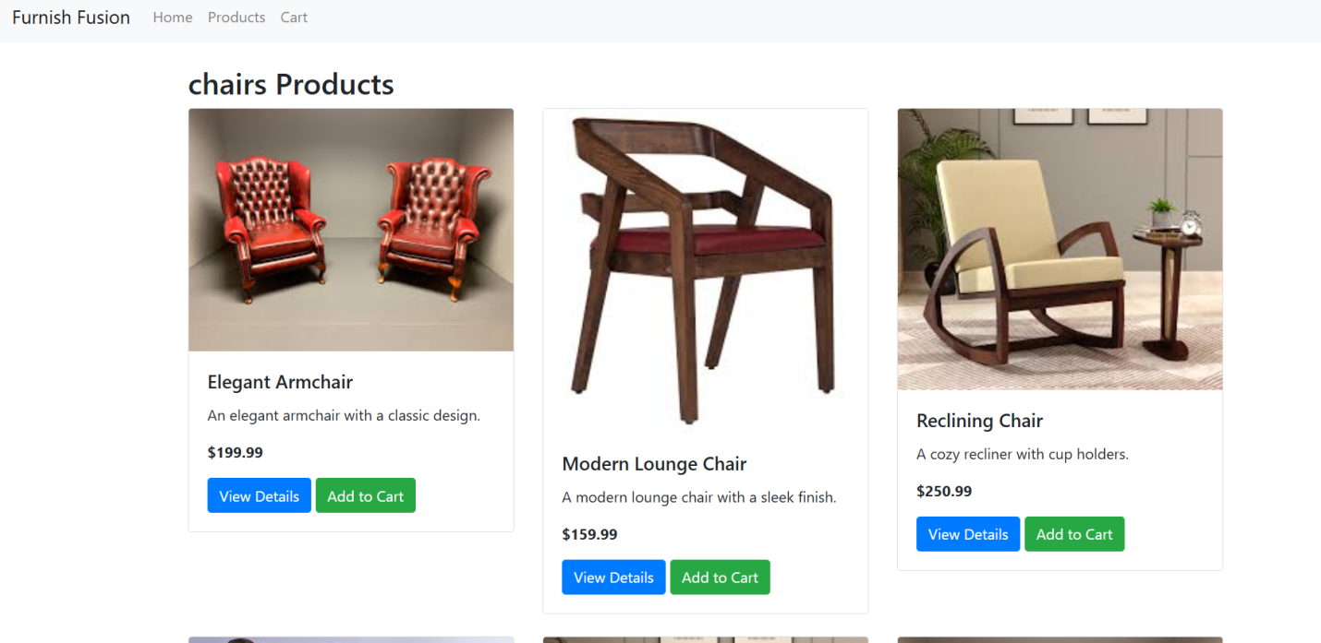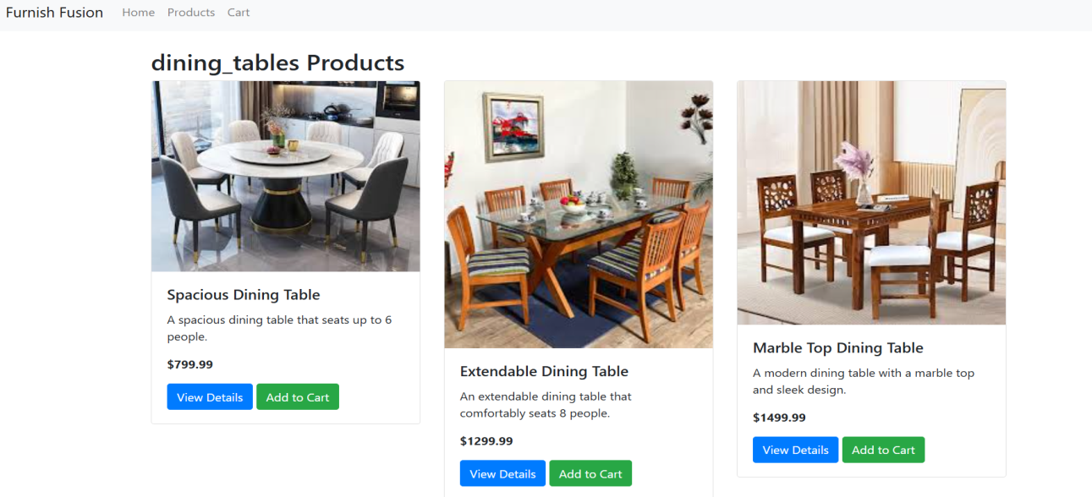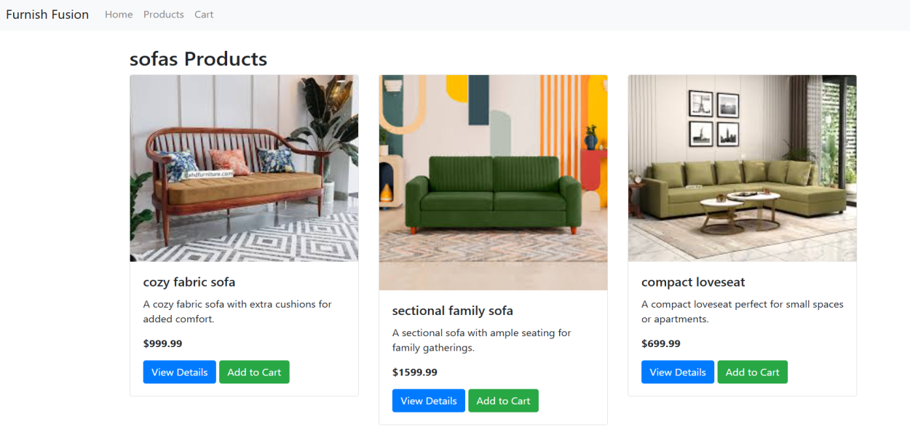

**Cart Page:**

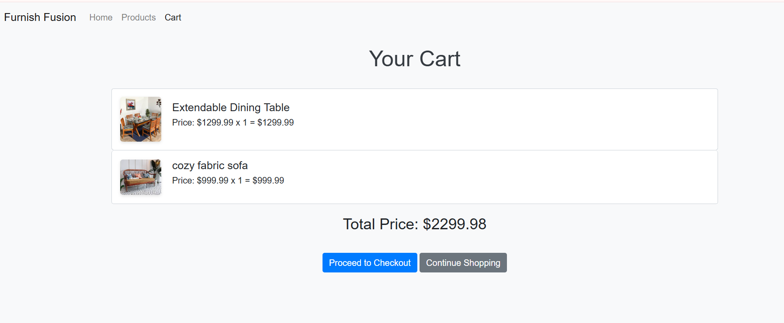  
**Buy now page:**

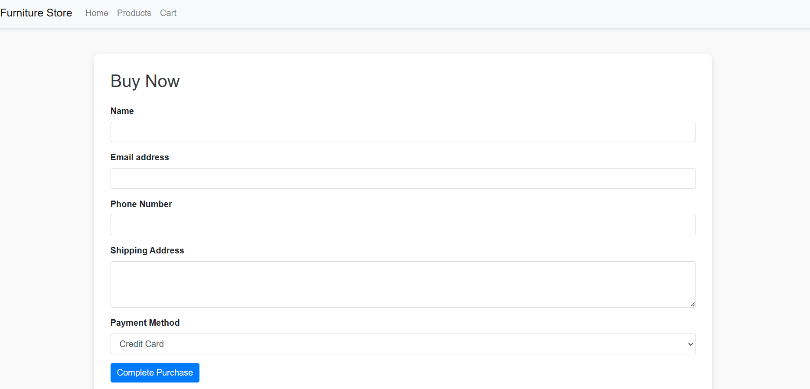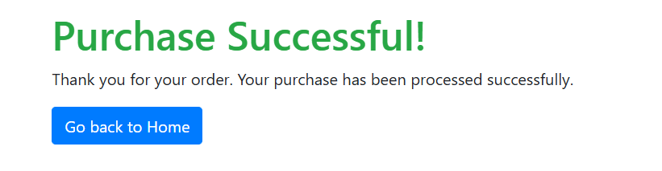

**Mail:**

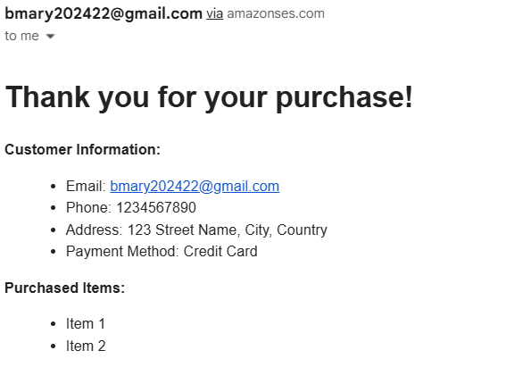

**DynamoDB updations :**

1. **Furniture table :**

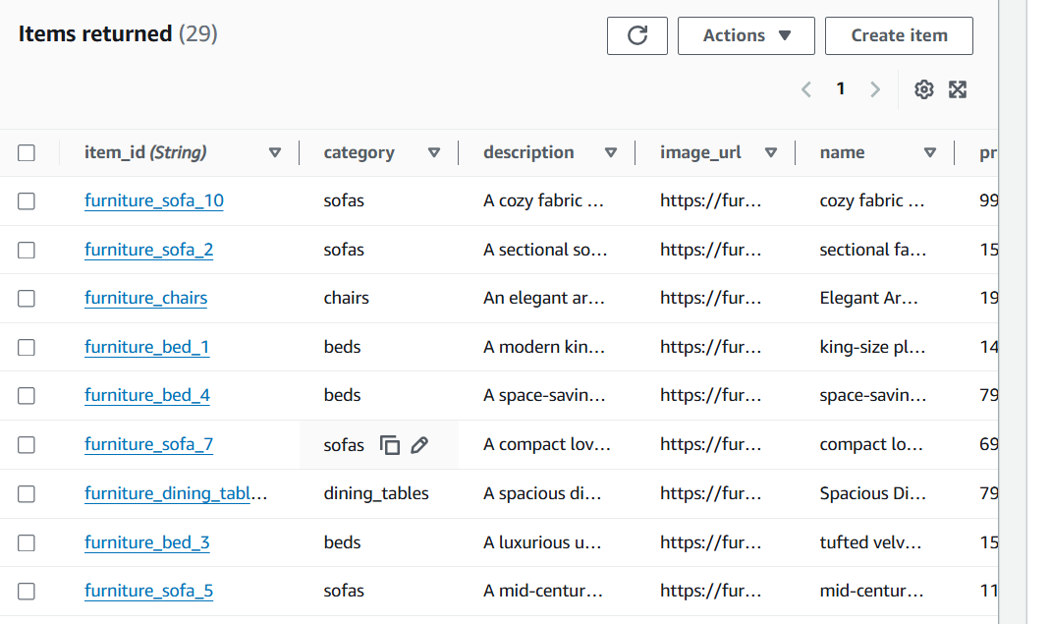

1. **Customer table :**

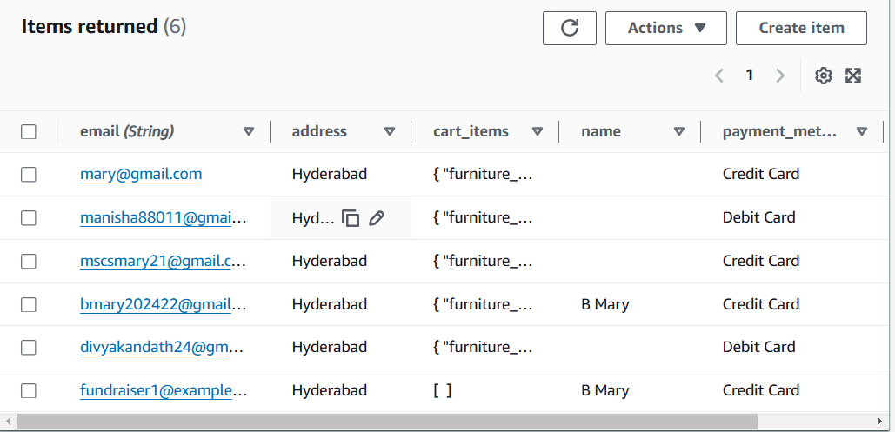

**Conclusion:**

The Furnish Fusion application has been successfully developed and deployed utilizing a robust cloud-based architecture with AWS services, including EC2 for hosting, DynamoDB for relational data management, and S3 for secure storage of design assets. This platform transforms the interior design process by allowing users to visualize and customize their spaces in real time while facilitating collaboration between designers and clients. The cloud-native design ensures exceptional performance and scalability, enabling the application to handle increasing user engagement without compromising functionality. Rigorous testing has confirmed that all features, from user onboarding to project management, function seamlessly. Ultimately, Furnish Fusion illustrates the power of cloud-based solutions to revolutionize the interior design industry, enhancing user experience and fostering efficient collaboration.